

*First Author: Alex Atkinson*

*| 13 Palace road, East Molesey, Surrey, KT8 9DJ, United Kingdom| alexatkinson1994@hotmail.co.uk | +44 7523208980 |*

*How online video advertising affects purchase intent.*

Alex Atkinson

In affiliation with

In partial fulfilment of the requirements of the award of BA (Hons)

Advertising

CMC Academic Group

Faculty of Media and Communication

Bournemouth University

2015/2016

*I declare that this dissertation/project is all my own work and the sources of information and the material I have used (including the internet) have been fully identified and properly acknowledged. I also declare that the hard copy and online submission of the dissertation are identical to one another.*

Student signature ………………………………………………………



**How online video advertising affects purchase intent.**

A dissertation submitted by

**Alex Atkinson**

4443555

In partial fulfilment of the requirements of the award of BA (Hons)

Advertising

CMC Academic Group

Faculty of Media and Communication

Bournemouth University

2015/2016

**Abstract**

Online video advertising can be defined as audio visual content that is distributed via the internet. In its basic form, this can be TV ads run online, but adverts are increasingly adapted or created specifically. They are placed before (pre-roll), during (mid-roll) and after (post-roll) video content. Digital advertising is gaining increasing significance, particularly with the growth of video advertising. Reports have shown that online video adverts increase purchase intent, but with no explanation on how this is achieved. The overall aim of this research study was to determine how online video adverts affect purchase intent.

Furthermore, this study has arisen because there is plenty of literature that has explored other advertising channels and how they can drive purchase consideration. A gap in the literature prevails despite video being the second largest format in digital advertising and its continual growth.

Quantitative research was carried out, drawing on a number of relevant studies that devised means for measuring advertising value and were tested in the research (Ducoffe 1995; 1996; Logan et al. 2012; Goodrich et al. 2015). A survey research method was carried out on 18-30 year-olds to measure the participant’s responses to attitudes and perceptions upon watching a high and low involvement pre-roll ad. Reasoning for carrying out an online survey was done in order to imitate the effects of watching a pre-roll advert. Statistical and correlational analysis’ were performed using SPSS to measure the particular characteristics (identified in the literature) and attitudes against purchase intent. The findings presented differences in the relationship of the characteristics that drive purchase intent: high involvement adverts must be informative whereas low involvement must be entertaining. Equally the descriptive statistics highlighted the strength of low involvement adverts in triggering purchase intention.

Two models will be provided to satisfy the high and low involvement decision-making processes in the conclusion. The study is significant because it offers a commercial value in understanding the process involved in triggering purchase intent for pre-roll video adverts, thus increasing effectiveness. Practitioners can use this framework to be incorporated into message strategy. The framework calls on further research to test the strengths and limitations of the model.

**Keywords**

Online video adverts= OVA

Advertising Value Model= AVM

Statistical Package for the Social Sciences =SPSS

**Contents**

1 Introduction 8

1.1 Growth of Digital Advertising in the UK 8

1.2 Online video advertising 8

1.3 Pre-roll video advertising and purchase intent 9

1.4 Research Purpose 10

1.5 Structure 10

2 Literature Review 12

2.1 Introduction 12

2.2 Consumer Behaviour 12

2.3 Online video advertising 14

2.4 Measuring purchase intent online 16

3 Methodology 19

3.1 Overview 19

3.2 Research Plan 19

3.3 Scope of Research 19

3.4 Research philosophy: Positivist 19

3.5 Research approach: Deductive 20

3.6 Research strategy: Survey 20

3.7 Sampling Approach and Size 20

3.8 Online questionnaire 21

3.9 Procedure 22

4 Findings 25

4.1 Overview 25

4.2 Gender 26

4.3 Age 26

4.4 Final Sample 26

4.5 Brand Awareness Test 26

4.6 Significance Test on High Involvement Adverts 27

4.7 Objective 1: To understand how the characteristics of an OVA affect purchase intent. 28

4.7.1 How do characteristics of OVAs affect purchase intention? 28

4.7.2 Low Involvement Findings 29

4.8 Objective 2: To understand how attitudes affect purchase intent. 29

4.8.1 How do attitudes affect purchase intentions? 29

4.8.2 High involvement 29

4.8.3 Low Involvement 30

4.9 Objective 3: To determine the role of high and low involvement adverts in triggering purchase intent. 30

4.9.1 Comparing the effectiveness of high and low involvement adverts in causing purchase intent for males. 31

4.9.2 Comparing the effectiveness of high and low involvement adverts in driving purchase intent for Females. 31

4.10 Discussion 31

4.10.1 Objective 1: To understand how the characteristics of an OVA affect purchase intent. 32

4.10.2 Objective 2: To understand how attitudes affect purchase intent. 34

4.10.3 Objective 3: To determine the role of high and low involvement adverts in triggering purchase intent. 35

4.11 Limitations of the current study 36

4.12 Recommendations for further research 37

5 Conclusion 38

5.1 Summary 38

5.2 Proposed Framework: Planning Model for Purchase Intent 38

5.3 Managerial Implications 40

6 References 41

7 Appendices 49

8 Research Ethics Forms 68

9 Manuscript 69

# Introduction

* 1. Growth of Digital Advertising in the UK

The UK Internet advertising market is experiencing a period of rapid growth (Keynote 2015). According to the International Advertising Bureau between 2004-2014, digital advertising spend increased by 800%, to £7.2billion. In addition, 40p of every £1 spent in UK advertising is spent on digital (IAB 2015). This makes the internet advertising sector the largest in the UK advertising market as illustrated in figure 1 (Keynote 2015). Digital advertising spend in the UK was recorded at £8.3billion in 2015, Mintel has forecast total expenditure will surpass £14.1billion by 2020 (Mintel 2016).

**[Insert figure 1]**

Online advertising channels have emerged as a powerful platform for advertisers, due to their responsive nature and ability to constantly evolve over time (IAB 2015). Equally, the market has been boosted by a surge in new technologies and service-providers, enabling more users to gain access to superfast broadband and 4G mobile networks (Keynote 2015). The range of formats (figure 2), combined with readily available online measurement opportunities means that advertisers can make informed choices about advertising formats based on key branding goals (Spalding et al 2009).

**[Insert figure 2]**

* 1. Online video advertising

More specifically, online video advertising is the second largest format of digital advertising (figure 2) and has seen continuous development, highlighted by its exponential growth from £12million in 2008 to £442million in 2014 (Chester 2015). It is forecast to be worth over £800million by the end of 2016 (McDonald 2015).

Online video adverts (OVA) are a form of rich-media and provide viewers with the “combined effects of the branding power of a traditional TV commercial and the interactive power of the Internet” (Lee et al. 2013, p. 2). Leading brands and agencies have embraced the value proposition of digital videos and are shifting their spend towards the format with its engaging content and advanced targeting capabilities. This is made ever-more desirable as users are watching more web-based video ads than ever (Chester 2015; Li and Lo 2015).

Within online video, in-stream spend is excelling as the largest contributor towards the advertising revenue stream (figure 3). Li and Lo (2015 p. 208) define one form of online video advertising, in-stream, these can be shown prior to the video being viewed (pre-roll). A key characteristic of a pre-roll is the prevention of fast-forwarding, the defining characteristic is the “difficulty the user has ignoring them”.

**[Insert figure 3]**

* 1. Pre-roll video advertising and purchase intent

Pre-roll video advertising is having an impact on purchase intent. A popular opinion on the strength of pre-roll video advertising is illustrated in a recent report by Google (2015). In Google’s report on the benefits of using their pre-roll delivery platform, TrueView, their results indicate that when watching a pre-roll video advert, there is a change in purchase intent in terms of lift and difference (appendix 1) (Giordano et al. 2015).

However, very few studies have explored the impact of online video advertising and how it affects purchase intent. According to Spears and Singh (2004), intentions are distinct from attitudes because they focus on the motivation that exerts a specific behavioural action. Therefore, “purchase intentions are an individual’s conscious plan to make an effort to purchase a brand” (Spears and Singh 2004, p. 56). These are analysed in the literature review from a consumer behaviour perspective, to understand why people consider purchase intentions when watching OVAs.

* 1. Research Purpose

To date, no research has been conducted into how a pre-roll video advert creates a lift in purchase intent, after a single viewing. Therefore, this paper explores how pre-roll video advertising can trigger purchase intent.

* 1. Structure

A literature review will be carried out to identify the antecedents that affect purchase intent, the variables identified will inform the methodology and then be tested in research. The findings will measure the results and establish the value of the variables in triggering a purchase intent with pre-roll video adverts. Finally, a framework will be created that can be used to increase the behavioural effectiveness of a pre-roll advert.

**Research Aim:**

To understand a viewers behavioural response when they watch a pre-roll video advert and to identify how this affects purchase intent.

**Research objectives:**

1. To understand how the OVA characteristics affect purchase intent.
2. To understand how attitudes affect purchase intent.
3. To compare the role of high and low involvement adverts in driving purchase intent.

# Literature Review

* 1. Introduction

The literature selected, is to understand the consumer decision making processes, followed by an exploration of OVA studies to establish what is already known, and investigation of measurement and effectiveness tools that supports objectives 1 and 2. However a gap is presented in objective 3 that will be explored further in the study.

* 1. Consumer Behaviour

In order to understand how an OVAs affects consumer’s intentions to purchase a product or service, consumer behaviour models must be explored. Solomon et al. (2013 p.3) defines consumer behaviour as the “process involved when individuals or groups select, purchase, use or dispose of products, services, ideas or experiences to satisfy needs or desires”. Indeed, consumer decision making is key in crafting effective marketing communications. For the most part, Fill (2013 p. 88) asserts that first and foremost, to engage with the intended target audience, information about the consumers’ decision making process must be acquired. Consumer decision-making can be classified into three categories: cognitive (learn), affective (feel) and behavioural (do) actions (Solomon 2015). These three categories represent the ABC Model of Attitudes referred to in table 2.11.

A number of studies have explored consumer behaviour models in the context of online video advertising to understand their effects on the consumer, outlined in table 2.11.

**[Insert table 2.11 in landscape format]**

In summary, these models have been effective in establishing that attitudinal variables are necessary to predict behavioural intentions. This is a valuable insight in providing an understanding of the overarching aim of the paper because purchase intent exists in the lead-up to behavioural action. The literature on consumer behaviour has emphasised the need to understand the ways users make a decision and factors impacting the decision processes. According to Fill (2013), these facets can be used to influence the effectiveness of marketing communications and are key in answering objective 1.

One criticism of much of the literature on consumer behaviour is that the most prominent models presented are limited in their approach. Solomon et al (2013, p. 315), accounts for the issue of decision-making, because consumers do not follow an “elaborate sequence every time they buy something… other purchase behaviours are undertaken with virtually no advance planning at all.” Therefore, literature on consumer behaviour has emphasised the need to understand the ways in which buyers make decisions and factors that impact upon the decision processes. However, there is very limited academia that addresses these models in the context of online video advertising and addressed behaviour intentions aside from watching an OVA. Fill (2013 p.97) argues the consumer behaviour models are “based on classical research supported by empirical research and don’t account for the development since the digital era”. Therefore, questions are raised about previous models’ validity in the contemporary world, offering a gap for further research.

* 1. Online video advertising

The following section explores the literature attempting to explain how consumer decision-making affects OVAs. According to Chatterjee (2001), consumer interaction with online adverts can be categorized into stages: pre-attention, attention, and behavioural decision. The research published in advertising journals so far shows that online advertising researchers have explored cognitive and affective components of OVAs, but they do not pay much attention to the conative component as a key tool of advertising. To date, a number of studies have investigated the drivers of awareness and engagement within online video advertising (Lee and Lee 2011; Teixeira 2012; Lee et al. 2013; Nelson-Field et al. 2013; Li and Lo 2015). For example, Teixeira (2012) findings show that emotions can be leveraged to encourage sharing and engagement. Equally seeding strategies (Rollins et al. 2014) and pass-along behaviours (Lee et al 2013) are some of the means for building awareness. Despite these findings, the research has clearly addressed the earlier stages of the consumer decision-making journey and is impractical in understanding how purchase intents can be triggered.

Lee and Lee (2011) identified six outcomes from watching OVAs (figure 4) that reflected the similar needs when using the internet and advertising (entertainment, information, relaxation, escape, passing time and social interaction). Their findings illustrated that more participants believed that watching OVAs would entertain them, the more positive their attitudes were towards watching OVA. This positively influenced a consumer’s intention to watch OVAs directly and reinforced the analysis carried out on the ABC Model of Attitudes and TRA Model. Despite new knowledge about the role positive attitudes play in encouraging pass-along behaviours, this study is useful in reinforcing Agarwal and Malhotra’s (2005 p. 491) stance that, “attitudes play an important role in influencing all aspects of consumer behaviour”. This gives reason to suggest that attitudes are crucial in understanding how OVAs affect purchase intention.

In summary, this study demonstrated an understanding of how attitudes affect intentions and will be tested in the research to determine if this aligns with OVAs and purchase intent, in answering objective 2.

**[Insert figure 4]**

* 1. Measuring purchase intent online

Chaffey and Ellis Chadwick (2012 points out that digital marketing offers more precise tools for measuring effectiveness versus offline. Tools of measurement such as click-through rate (CTR) are commonly used but are weak. Hollis and Briggs (1997) identified the best measure of advertising response on the web is a click-through rate (CTR) because it represents a behavioural response and is easy to observe. However, this measure has its limitations. CTR is an ambiguous means for measuring response towards the lead up to purchase intent. It fails to explain the implicit factors present as a result of the audience’s predisposition (emotions and behaviours) rather than with the advertising itself (Hollis and Briggs 1997; Idemudia 2014). This linear measuring tool fails to elaborate on the facets of purchase intent.

Spears and Singh (2013) identified a more apposite measure for measuring purchase intent that focused on testing attitudes against intentions to purchase (appendix 2). These tools offer an understanding of the relationship between variable and intentions to purchase and will be considered in satisfying objective 1 and 2.

Furthermore, Ducoffe’s (1995; 1996) Advertising Value Model (AVM) (figure 5) remains a useful indicator for measuring the effectiveness of an advert. Although originally published in 1995, Ducoffe’s framework for measuring advertising value identified three correlative components, informativeness, irritation and entertainment. The AVM has been developed and modified for application across contemporary advertising channels (Logan et al. 2012; Goodrich et al. 2015).

**[Insert figure 5]**

Logan et al (2012) applied the AVM to compare Facebook against television adverts, in exploring advertising value perceptions among females. However, findings showed that the AVM was not comprehensive in assessing advertising value for these channels because only two of the three components (entertainment and informativeness) had a key role in assessing the value for both traditional and non-traditional channels. Whereas, irritation had an insignificant role in value assessment and was found to directly impact attitude towards advertising, a critical stage in the purchase cycle.

Conversely, Goodrich et al (2015) offers a more substantial development to the AVM for measuring the effectiveness of an advert (Ducoffe 1995; 1996). The study explores consumer reactions to intrusiveness with OVAs and how the variables (length, informativeness, and humour) can affect market outcomes for good or worse (appendix 3). It was useful in finding that intrusiveness/irritation negatively affects attitudes and intentions. Therefore, irritation will be included to substantiate the research that it being tested for objective 2.

Additionally, the study focuses on addressing OVAs and is useful in establishing their characteristics (figure 6). Nonetheless, the literature was limited when referring back to Ducoffe (1995; 1996) and Logan et al. (2012), because it fails to explore the relationship between the attitudinal variables and characteristics in the context of OVAs. Therefore, an opportunity is presented in the literature to apply these variables in the research study.

**[Insert figure 6]**

This chapter has explored existing literature from the fields of consumer behaviour and online advertising. A number of key issues have been presented, notably the lack of understanding upon how OVAs can affect a purchase intention. As identified, the systems for measuring online purchasing intent have developed in line with technological advances. Whilst the literature appears to support the identification of the antecedents that affect purchase intent (Ducoffe 1995; Logan et al 2012; Goodrich et al 2015), this study aims to test this assumption within the context of pre-roll advertising.

Therefore, the research approach will draw on these identified variables to test the relationship between the two facets (attitudes and characteristics) on purchase intent in the context of pre-roll video ads.

# Methodology

* 1. Overview

The following chapter sets out the research aims and objectives, and forms an appropriate methodology, summarized in the flow diagram (figure 7). Saunders et al. (2012) research onion was used to inform the research design (appendix 4).

**[Insert figure 7]**

* 1. Research Plan

**[Insert table 3.2]**

* 1. Scope of Research

Due to restrictions in funding and resources, generalisations are restricted. Therefore, Statista’s (2016) data for the first quarter of 2012 established that 93% of 16-24 year olds and 94% of 25-34 year olds had watched an online video in the preceding month (see figure 8). Therefore, a more appropriate sampling parameter was chosen to cover 18-30 year olds.

**[Insert figure 8]**

* 1. Research philosophy: Positivist

A positivist stance draws on existing knowledge (Saunders et al. 2012), therefore this research draws on the work of Ducoffe’s AVM (1995); Logan et al. (2012); Spears and Singh (2013); Goodrich et al. (2015) to understand the tools for measuring the effectiveness and value of advertising.

* 1. Research approach: Deductive

The research will follow a deductive approach, using existing theory that is applied to rigorous testing (Saunders et al 2012). A deductive approach was chosen because the literature review revealed a number of theoretical frameworks and values that informed the research questions and objectives (see section 3.2). These questions will be applied and tested against a number of hypothesis questions that will provide an informed speculation about the possible relationship between the variables established from the literature (Bryman and Bell 2011).

* 1. Research strategy: Survey

The survey strategy is typically used for collecting data, as it can then be analysed quantitatively using descriptive and inferential statistics (Saunders et al 2012). This study will use a web-based survey. Prospective respondents will be invited to visit a website where the questionnaire can be found and completed (Bryman and Bell 2011).

* 1. Sampling Approach and Size

A non-probability sampling was employed to reach out to participants aged between 18-30. Screening techniques will be used to ensure that participants have watched an online advert at least once before, to warrant relevance in the findings.

A sampling frame of 100 participants was drawn up. Social media and email were used to invite participants to take part in the online questionnaire. Users were informed that participation in the study was completely voluntary (appendix 5). Incentives were offered to increase completion rates due to time restrictions, provided participants completed the survey. Incentives can influence response rates either by facilitating contact with potential respondents, or by stimulating their cooperation (Singer 2013).

It was appropriate to reach out to the sample through online techniques because they offered access to respondents who may not be as easily available through traditional research approaches (Bradley 2013). A judgment sampling method was used to contact respondents, with the researcher making decisions about who might best help in the study (Bradley 2013). In order to identify suitable respondents, an invitation message was sent out to individuals matching the sample criteria (18-30 year olds). A screening question asked the selected participants if they had ever watched an online video advert before (appendix 6); if answered Yes, participants were invited to take part in the survey.Social media was used to drive traffic to the survey and consequently increase the response rate.

The sampling method has its limitations because of the lack of raw data. But the method was beneficial in this scenario because it allowed for a larger number of responses to be gathered comparatively quickly and cheaply (Walliman 2010). Thereby working within the financial and time constraints of the dissertation process.

* 1. Online questionnaire

The online questionnaire was intuitively designed to automatically repopulate the subsequent question depending on participant’s answers (figure 9). Likert scale questions were followed up with open-ended questions, personalised specifically to categorise a response to enable further elaboration and insights (Bryman and Bell 2011). This is especially helpful when conducting longer surveys (Weissbach 1997).

**[Insert figure 9]**

* 1. Procedure

Participants were required to watch two pre-roll adverts at separate stages during the survey. These consisted of a high and low involvement advert that were tested in order to satisfy objective 3. Otnes et al. (1997) suggests that there is a gender difference in processing under high-involvement conditions. Thus, two high involvement adverts were included for male and female viewers (figure 10 and 11). The design of the questionnaire enabled different videos to be presented, dependent on the participant’s response to the gender question.

To ensure results were not skewed by brand pre-conceptions. Online video adverts with a low brand awareness were selected and screening questions were implemented to ensure participants had not seen the brand before (appendix 7).

**[Insert figure 10]**

**[Insert figure 11]**

On the other hand, for the low-involvement advert, purchases are typically made with no planning or previous thought (Tanner and Raymond 2012). A Fast-Moving Consumer Good (FMCG) brand was designated (figure 12).

**[Insert figure 12]**

Playback controls were removed on the videos in order to imitate the format of a pre-roll advert where, “fast-forwarding is often prevented” (Li and Lo 2015 p. 208) and 30 seconds long. The research design process undertaken, leads participants away from the survey during the questionnaire, to watch a pre-roll advert and then return back to respond with a series of questions as illustrated in figure 13.

**[Insert figure 13]**

**3.9 Ethical Considerations**

This study was granted full ethical approval by Bournemouth University’s ethics board (appendix 8). To ensure participants confidentially all email addresses provided through the incentive draw were stored securely.

**3.10 Data analysis**

A benefit of using a survey, rather than any other method, is that surveys are relatively straightforward to analyse (Wilson and Mclean 1994). The data collected was conducted through Statistical Package for the Social Sciences (SPSS) by downloading the data acquired from the typeform questionnaires, running it through IBM SPSS v23, to be measured and analysed using a set of non-parametric tests (Bryman and Bell 2011). A set of non-parametric tests was appropriate for measuring the findings since a number of hypothesis questions were tested to draw correlations (appendix 9). A lot of this data is being driven by quantitative data, so as not to prime the audiences, a verbatim was collected as a survey technique.

**3.11 Reliability and Validity**

As reliability is fundamentally concerned with issues around the consistency of measures (Bryman and Bell 2011), pre-test and pilot studies were used to survey a small subset of the sample population. This was to determine whether the research instrument, and method used to collect the data, was relevant, reliable and valid (Du Plooy, 2009; Bhattacherjee, 2012). The questionnaire was pre-tested by 10 respondents to check the reliability of the scales, wording and questions. The structure was amended and questions were reworded because of a difficulty understanding the meaning. The pilot survey was used to ensure the research collected the correct data required. The pilot was tested in a web-based survey using typeform, whereby users could access the survey via a specific link. This method of distributing the survey was chosen because web-based surveys have the potential to reach a greater audience (Cohen et al 2007).

The choice of strategy offers a series of benefits, because it is hosted on typeform (web-based survey programme), the responses are automatically collected in a database for analysis, which can save time and reduce the risk of errors in data inputting (Davies and Hughes 2014 p. 93). Additionally, web surveys seen to be more reliable than other types of research strategy in reducing interviewer bias (Forrest 1999).

To validate the findings, the survey instrument included measures related to the perceived attitudes towards both high and low involvement adverts, by showing their intentions to purchase the product and reasons why they felt that way. The data collected was measured through a Likert scale, a widely used format develop for asking attitude questions (Sapsford and Jupp 2006). Respondents were asked the degree to which they agreed with the series of statements against a multiple-indicator or item measurement scale. The scale was deemed then to measure the intensity respondents felt about an issue (Bryman and Bell 2011).

The independent variables identified from Ducoffe’s (1995; 1996) AVM were measured by adapting established scales used in previous studies to assess the perceived informativeness, entertainment, irritation perceptions from respondents (figure 5). Participants were required to respond to seven-point, Likert-type scales, by selecting the option that best represented how the they felt about the pre-roll advert viewed (1= Strong disagree, 7= Strongly Agree). On the other hand, the dependent variables were measured using a five-item established scale regarding attitudes (1= Very Negative 5= Very Positive). (Laczniak and Muehling 1993). Sub-items within each scale were averaged, resulting in composite scales. A Likert scale measure ensures reliability because the data is presented more clearly (Sapsford and Jupp 2006).

**3.12 Limitations**

A considerable challenge is the often questionable sample reached through online methods, there are few indicators that the sample respondents met the sample age especially when incentives were offered to complete the questionnaire and it is difficult to verify the sample since this is an online survey (Blumberg et al 2014). However, there were time constraints for gathering primary research and while this is a limitation of web surveys, it offers a means for gathering response data in a short amount of time (Davies and Hughes 2014 p. 93). Possible limitations including truthfulness are out of control in a web based survey (Forest 1999).

# Findings

* 1. Overview

This chapter will present, evaluate and discuss the findings gathered from the primary data conducted through online questionnaires. The chapter will begin by reporting the findings associated with research objectives, followed by a discussion section analysing the findings and outcomes with regard to how pre-roll adverts affect purchase intent. The quantitative data will be analysed from a variety of means tested using SPSS in order to answer the research objectives.

**Research Questions**

1. To understand how the OVA characteristics affect purchase intent.
2. To understand how attitudes affect purchase intent.
3. To compare the role of high and low involvement adverts in driving purchase intent.
   1. Gender

The figure below (figure 14) presents an overview of the respondents’ gender and highlights that a balanced gender ratio was achieved, which increases the validity of the findings. This is important for the analysis because part of the research design method meant that the first high involvement advert would be split based on gender. A balanced sample creates a fairer representation of the data for further analysis.

**[Insert figure 14]**

* 1. Age

It is apparent from figure 15 that there were more 18-25 year-old respondents. For future reference a more controlled sample should be carried out.

**[Insert figure 15]**

* 1. Final Sample

150 questionnaires were distributed to participants aged between 18-30 through social media and email channels. 103 participants responded to the questionnaires but two of the responses were screened out, therefore 101 responses were collected. This ultimately meant that there was a 71% response accuracy (appendix 10). The incentives offered in the questionnaire may have heightened the response rate (Singer 2013).

* 1. Brand Awareness Test

A low brand awareness was achieved for all three adverts showcased in the survey (figure 16).

**[Insert figure 16]**

* 1. Significance Test on High Involvement Adverts

The figure below illustrates a series of significant tests between male and female respondents. A Mann-Whitney U test was carried out to measure the significance of the relationship between the high involvement adverts viewed separately by male and female respondents (appendix 11). The test established a need to analyse the two genders separately to ensure validity.

A Mann-Whitney U test indicated that the level of entertainment was not significant between males and females viewing the high involvements adverts (U= 1059.500; N1= 48; N2= 53; p= .138). Whereas there was significance between informativeness for male and females (U= 657.000; N1= 48; N1= 53; p= >.000). In addition, levels of irritation were not significant for the two genders (U= 1194.500; N1= 48; N2= 53; p= .581).

The test was also used to examine the relationship of significance between the attitudes of the two high involvement adverts. The results show no significance for pre-existing attitudes between male and females (U= 1194.500; N1= 48; N2= 53; p= .581). Furthermore, likeability presented as insignificant (U= 1270.000) N1= 48; N2= 53; p= .989). Finally, the results indicate no significance in purchase consideration between the two high involvement adverts (U= 1129.000; N1= 48; N2= 53; p= .299).

In all cases, there are differences in significance between the two high involvement ads for male and female and therefore both genders must be analysed separately in the following research questions.

* 1. Objective 1: To understand how the characteristics of an OVA affect purchase intent.

The following objective reported the significance of the variables against purchase consideration and then tested for a correlation. It is apparent that there is a relationship between the independent variables (entertainment, informativeness and irritation) and intentions to purchase the products seen in the ad.

### How do characteristics of OVAs affect purchase intention?

A Spearman correlation test was conducted on the male respondents who viewed the high involvement advert (appendix 12). The test indicated that there was a weak, but significant correlation between entertainment and purchase consideration: rs= .266, n= 48, p=.034. A weak, but significant correlation showed between informativeness and purchase consideration: rs= .334, n= 48, p= .010. Whereas a weak, but significant, negative correlation was established between irritation and purchase consideration: rs= -0.037, n= 48 p= .009 accepting the null hypothesis.

A Spearman correlation test was also conducted on the female respondents (appendix 13). The results indicated that, there was a weak, but significant correlation between entertainment and purchase consideration: rs= .397, n= 53, p.034. In addition, a moderate and significant correlation between informativeness and purchase consideration was evident: rs= .566, n= 566, p< .001. On the other hand, a very weak and insignificant, negative correlation was established between irritation and purchase consideration, insufficient in answering null hypothesis: rs= -0.037, n= 48 p< .009.

### Low Involvement Findings

If we now turn to the low involvement responses, another spearman correlation was tested (appendix 14). The findings demonstrate a moderate and significant correlation between entertainment and purchase consideration: rs= 0.592, n= 48, p>.001. However, a weak, but significant correlation between informativeness and purchase consideration: rs= 0.230, n=48, p>.001 was clear. On the other hand, a moderate, significant negative correlation was present between irritation and purchase consideration: rs= -.514, n=48, p>.001.

The female findings (appendix 15) displayed a strong and significant correlation between entertainment and consideration to purchase: rs= 0.641, n= 53, p> .001. A moderate and significant correlation between informativeness and purchase was also highlighted: rs= .415, n=53, p>.001. Nonetheless, a weak, but significant negative correlation was present between irritation and purchase consideration: rs= -.310, n=53, p<.12.

* 1. Objective 2: To understand how attitudes affect purchase intent.

The second objective measured the significance of the variables against purchase consideration and a correlation test was carried out between high and low involvement adverts. The results prove that positive attitudes are related to purchase intentions but don’t play a pivotal role in triggering purchase intent.

### How do attitudes affect purchase intentions?

### High involvement

A Spearman correlation was tested across high and low involvement ads to establish if attitudes affected intentions to purchase (appendix 16). The test presented a weak and insignificant correlation between attitudes about pre-roll adverts and purchase intent for males: rs= .236, n= 48, p< .001. A weak, but significant correlation was evident between likeability and purchase intent (rs= .298, n= 48, p< .001). The dependent variables indicate ‘slightly’ negative pre-existing attitudes about pre-roll adverts. Equally negative attitudes about the adverts were clear (M= 2.71).

Conversely, a weak and insignificant negative correlation between pre-existing attitudes and purchase consideration resulted (appendix 17): rs= -.221, n= 53, p= .056. A moderate, significant correlation was illustrated between likeability and intentions to purchase: rs= .583, n= 53, p< 001. Despite inconsistency in the dependent variables, the descriptive statistics both presented negative pre-existing attitudes (M= 2.04) and (M= 2.77) likeability in the the mean values, when compared to table 4.52, different correlations were highlighted.

### Low Involvement

A Spearman test (appendix 18) demonstrated a weak, but significant correlation between pre-existing attitudes and intentions to purchase for the male audience: rs= .266, n= 48, p= .034. A moderate and significant correlation was present between likeability of the advert and purchase consideration: rs= .557 n= 48, p< .001. A neutral attitude towards the advert was averaged (M= 3.46).

Nonetheless, there was a very weak and insignificant correlation amid pre-existing attitude and purchase intentions for females (appendix 19): rs= -.074, n= 53, p= 300. Although, a test between attitudes and intentions revealed a strong, and significant relationship: rs= .670, n=53, p< .001.

* 1. Objective 3: To determine the role of high and low involvement adverts in triggering purchase intent.

The final objective compared the role of the high and low involvement across both genders on the final question: “Would you consider purchasing the product seen in the advert?” The results indicate that the low involvement advert generated a much higher rate of purchase consideration in comparison to the high involvement ads (figure 17).

**[Insert figure 17]**

### Comparing the effectiveness of high and low involvement adverts in causing purchase intent for males.

A Wilcoxon Signed-Ranks Test (appendix 20) showed that the low involvement advert was significantly more effective in driving purchase intent in comparison to the high involvement for the male sample: W= 9.00; z= -4.965b,n= 48, p<.000.

### Comparing the effectiveness of high and low involvement adverts in driving purchase intent for Females.

The Wilcoxon Signed Rank Test (appendix 21) also showed that the low involvement was significantly more effective in driving purchase intent in comparison to the high involvement for the male sample: W= 33.00 z= -5.525e, n= 53, p= .000).

* 1. Discussion

In summary the findings chapter has tested the antecedents, characteristics of an OVA and attitudes identified in the literature to measure their relationship between purchase intent. The following results will be discussed.

### Objective 1: To understand how the characteristics of an OVA affect purchase intent.

The results found significance in the entertainment and informativeness variables, however the two compared differently in the Spearman correlation tests for high and low involvement adverts. A correlational analysis highlighted that the informativeness antecedent had the strongest correlation of the independent variables towards purchase consideration in the context of the high involvement adverts. Whereas, entertainment was significant but there was only a weak correlation in the results. Therefore, informativeness and entertainment both rejected the null hypothesis, but a stronger relationship was raised between informativeness and purchase intent. In support of these findings, high involvement decision-making requires an extensive information search after being exposed to a message (Rossiter el al 1991; Fill 2013), suggesting that a one-time viewing is insufficient in driving purchase intent. This will be explored further in objective 3.

For the low involvement advert there was significance in all three variables tested. The strongest correlation was emphasised between entertainment and purchase consideration. In comparison, informativeness represented a weaker correlation with purchase intent. Therefore, the findings suggest that the characteristics of low involvement adverts represent different values. These relationships are suggestive by Logan et al. (2012 p. 169), who points out that, “as established in media frameworks, such as the usages and gratifications theory, consumers and advertisers both seek benefits from entertaining advertising. Specifically, they believe that entertaining ads generate positive brand attitudes” (Logan et al 2012; Shimp, 1981; MacKenzie and Lutz, 1989; Shavitt et al., 1998). This was clearly orchestrated in the findings as respondents made positive reference to the brand (appendix 22).

On the other hand, irritation was inconsistent in the findings. The null hypothesis was accepted for male viewers but was insufficient in the female responses for the high involvement advert. More interestingly, a moderate but negative correlation in the low involvement findings would suggest that irritation is affected by how entertaining and informative the advert was perceived to be. These results are in line with those from previous studies (Ducoffe 1995; 1996; Logan et al. 2012; Goodrich et al. 2015). Logan et al. (2012 p.169) explains that, “while the informativeness and entertainment variables are positive predictors of the AVM, the irritation variable serves as a negative indicator.” Consequently, consumers are less likely to be persuaded by advertising that is perceived by negative indicators (Yeom et al. 1996).

This research aligns with Goodrich et al.’s (2015) findings that suggests that although irritation is a determining factor, the respondents assessed advertising value on the basis of informativeness and entertainment. Additionally, their findings demonstrated that the inclusion of useful information and entertaining traits in online advertisements significantly reduced intrusiveness. Therefore, irritation provides little use in predicting intentions to purchase but should be considered because it is affected by the independent variables.

The results from objective 1 indicate that entertainment and informativeness are crucial factors in affecting purchase intentions. Both types of adverts prove that irritation must be low to reduce the risk of negative perceptions and attitudes that can lower chance of a behavioural outcome for the receiver of the message. The results confirm that the independent variables affect purchase consideration, but differ for and high and low involvemen**t** adverts accordingly (figure 18).

**[Insert figure 18]**

### Objective 2: To understand how attitudes affect purchase intent.

In this study, pre-existing attitudes were insignificant for both types of adverts. These results are unsurprising and tie in with previous studies (Ducoffe 1995, 1996; Logan et al. 2012; Goodrich et al 2015) because the descriptive statistics presented a negative pre-existing attitude towards pre-roll adverts. One possible explanation can be rationalised through the TRA, where the best predictor of behaviour is intention and if negative attitudes are present (Fishbein and Ajzen 1975), which is clear in the descriptive statistics, then behavioural intent is unlikely to detract the user of the decision-making process. In summary, pre-existing attitudes are an insufficient predictor of purchase consideration, nor should they be considered for measuring purchase intent.

Another important finding showed a significance in the relationship between likeability and purchase intent. Several reports have shown that positive attitudes lead to more favorable intentions (Lee and Lee 2011; Chih 2008; Lee et al 2013) and there was a sufficient correlation in both types of adverts to confirm this. However, based on the strength of the correlation, attitudes cannot be considered a dependent measure of purchase intent.

To summarise, the dependent variable correlations have not been as conclusive in their relationship between purchase consideration when compared to the independent variables. The study did not find a significant difference between pre-existing attitudes and purchase intent, but did with attitudes towards the advert.

### Objective 3: To determine the role of high and low involvement adverts in triggering purchase intent.

A descriptive statistic test illustrated that the low involvement advert was almost twice as effective in triggering a purchase consideration for both genders (appendix 25). Interestingly, the mean response represented a “possible” consideration for purchasing the product seen in the advert. These findings are significant because research has failed to compare the effectiveness high and low involvement adverts with the goal of purchase intent. A possible strength is resulted from low levels of attention, with limited interruption in the consumer decision-making cycle (Heath 2001).

On the contrary, respondents on average, were unlikely to purchase the high involvement products, with similar mean averages for both genders. The general consensus of respondents on the high involvement advert mentioned a need to research the product and brand further because more information was needed on the product/brand (appendix 23 and 24). This is because high involvement adverts typically require trial behaviour and experimentation before attitudes can be formed (Krugman 1965; Fill 2013).

On the question of purchase consideration, a sum rank test was carried out to compare the effectiveness of the high and low involvement adverts tested in the study (appendix 20 and 21). The low involvement advert presented significantly higher purchase considerations. A number of external factors such as the type of content being shown and the respondents interests could have been a reason for the higher purchase consideration. Alternatively, a combination of these factors show that low-levels processing can be more effective when measured for purchase intent in a one-time viewing because individuals a low-level processing because of lowered risk, which can interrupt behavioural intent (Heath 2001; Fill 2013). Therefore, asking the respondents about the advert immediately after watching it and may have not be a true reflection when comparing high and low effectiveness.

A gap in the literature was presented on the role of high and low involvement adverts in triggering purchase intent. Assumptions can be made for the low involvement advert when it has been proven that entertainment was the driving independent variable. A “possible consideration to purchase” (appendix 25) was averaged in the findings, intriguingly, 80% of respondents found the advert amusing (appendix 26). Lee et al. (2013) study found that emotions and attitudes can drive behavioural actions. Goodrich et al. (2015 p.6) further supports this highlighting that, “entertainment qualities are important for recall, attention and, sometimes, attitudes, particularly in the food-and-beverage category”. A recommendation for further research should consider testing emotional antecedents against purchase intent.

The final objective has established that the low involvement advert was significantly more effective than the high involvement in driving purchase consideration. A possible account for this is because of involvement theory, but a need for further research is required to validate this finding.

This study has determined that online video adverts affect purchase intent and the measurement tools align with the results tested in previous studies. The conclusion has devised a framework that can be applied for measuring purchase intent.

* 1. Limitations of the current study

On the other hand, the results are not comprehensive enough to assert the strength of the particular variables and must be tested across different age groups, with a variety of adverts to enhance the credibility of the findings. Despite these promising results, a question asking people about their attitudes towards the product seen in the advert could have acted as extra insight in explaining how online video adverts affect purchase intent. Choosing a wider sample will mean that the findings can be generalised to the wider population (Matthews and Ross 2010).

* 1. Recommendations for further research

Future research should look at testing the variables across different age groups, expand the sample size and measure a greater variety of high and low involvement adverts to gain a more substantial insight into the significance and relationship of the independent variables and purchase intent. More research needs to be carried out on high and low involvement adverts to rationalize the findings. Equally, due to time and resource constraints, the study did not explore targeting and this represents a key strength of pre-roll adverts, highlighting an area for future research. There is a definite need for further research to be carried out in the field of digital advertising with a focus on purchase intent.

# Conclusion

* 1. Summary

The objective of this study was to determine **how online video advertising affected purchase intent.** The study made reference to pre-roll video advertising in providing an understanding of how the attitudes and characteristics affect purchase intent.

A systematic approach was undertaken to achieve the objectives testing existing frameworks and aligning them against the results. A particular emphasis was placed on the Advertising Value Model (Ducoffe 1995; 1996) and the literature furthered to more relevant channels, comparing TV and Facebook (Logan et al. 2012) with more usefully, online video advertising (Goodrich et al. 2015).

The objectives were successfully met, however, objective 3 needs further research due to lack of resources. The findings uncovered a relationship between the independent variables and purchase intent, particularly for low involvement ads, positive attitudes must exist.

**[Insert table 5.11]**

Overall this study strengthens the idea that purchase intent exists in online video advertising, but if understood further can be utilised to bring greater commercial value for OVAs. A call for more research needs to be carried out on digital video advertising.

* 1. Proposed Framework: Planning Model for Purchase Intent

This research provides a framework for measuring high and low involvement ads in triggering purchase intent. The models have been adapted from TRA (Fishbein and Ajzen 1975) and adaptations (Lee and Lee 2011; Logan et al. 2012). The model should be tested on a sample to measure the relative strength of the variable following the research methods undertaken in the study (figure 19 and 20).

1. Consider the independent variables for high involvement, informativeness must be greater than entertainment [figure 19] or in the case of the low involvement, entertainment must be greater than informativeness [figure 20].
2. Attitudes must be then considered and tested for likeability. A Likert scale is advised similar to the one carried out in the study (1= Negative, 5= Positive). The level of likeability will determine how strong a purchase intention can be.
3. If both types of variables meet the criteria served, then a purchase intention is likely.
4. The following stages are uncontrollable measures, but the purpose of these models are planning and driving purchase intent for pre-roll OVAs.

**[Insert figure 19]**

**[Insert figure 20]**

The framework has to be further tested in academia to establish its strengths and limitations. It is intended for practitioners to incorporate into message strategy. This framework is created to increase the commercial effectiveness of pre-roll video adverts, in order for the framework to be effective, practitioners must be clear about the level of decision-making required by consumers.

* 1. Managerial Implications

For high involvement adverts that pose a greater risk (Bauer et al. 2006; Fill 2013) the findings display a need to further satisfy high decision-making that is difficult to achieve in one viewing. Practitioners can offer means to maintain this journey with users. For example, TrueView introduced a new feature earlier last year (appendix 26) that offered a direct purchase on-screen (Peterson 2015). This presents an effective tool, however in light of the research findings, may be insufficient as high involvement products require research and time to consider. A more suitable method would consider incorporate a call-to-action icon driving further purchase consideration. This could be as simple as offering a visual link to a microsite that offers more information about the product, an email sign-up or social media plugins (like or follow). See figure 21 and 22 for indicative call-to-action concepts. Recommendations for low involvement brand are to continue driving entertainment values.

**[Insert figure 21]**

**[Insert figure 22]**

# References

Agarwal, J., & Malhotra, N. K. (2005). Integration of attitude and affect: An integrated model of preference, intention, and choice. *Journal of Business Research*, 58(4), 477-482.

Ajzen, I., & Fishbein, M. (1980). Understanding attitudes and predicting social behavior. *Englewood Cliffs, NJ: Prentice-Hall*.

Bagozzi, R.P., Baumgartner. and Yi, Y., 1992. State versus Action Orientation and the Theory of Reasoned Action: An Application to Coupon Usage. *Journal of Consumer Research*, 18, 505-518.

Bauer, H. H., Sauer, N. E., and Becker, C., 2006. Investigating the relationship between product involvement and consumer decision-making styles. *Journal of Consumer Behaviour*, 5 (4), 342–354.

Bearden, W. O. and Oliver, R. L., 1985. The Role of Public and Private Complaining in Satisfaction with Problem Resolution. *Journal of Consumer Affairs*, 19 (2), 222–240.

Bhattacherjee, A., 2012. *Social Science Research: Principles, Methods, and Practices*. Second edition. CreateSpace Independent Publishing Platform.

Blumberg, B., Cooper, D.R., and Schindler, P.S., 2014. *Business research methods*. Fourth edition. London: McGraw-Hill Education.

Bradley, N., 2013. *Marketing research: tools & techniques* [online]. Third edition. Oxford: Oxford University Press. Available from: http://capitadiscovery.co.uk/bournemouth-ac/items/822772 [Accessed 9 Apr 2016].

Branding Goals. *Journal of Advertising Research*, 49 (3), 285–292.

Bryman, A. and Bell, E., 2011. *Business research methods* [online]. 3rd ed. Oxford: Oxford University Press. Available from: http://capitadiscovery.co.uk/bournemouth-ac/items/484687 [Accessed 11 Mar 2016].

Chaffey, D. and Ellis-Chadwick, F., 2012. *Digital Marketing: Strategy, Implementation and Practice*. Fifth Edition. Harlow: Pearson.

Chatterjee, P., 2001. *Online Reviews: Do Consumers Use Them?* [online]. *Association for Consumer Research*, 28, 129-133.

Chester, S., 2015. *Video Marketing* [online]. London: Internet Advertising Bureau. Available from: <http://www.iabuk.net/disciplines/video-marketing> [Accessed 20 April 2016].

Choo, H., Chung, J. and Pysarchik, T., 2004. Antecedents to new food product purchasing behavior among innovator groups in India. *European Journal of Marketing*, 38 5/6, 608 – 625.

Cohen, L., Manion, L. and Morrison, K., 2007. *Research Methods in Education*. Sixth edition. London: Routledge.

Conner, M., & Armitage, C. J., 1998. Extending the theory of planned behavior: A review and avenues for further research. *Journal of Applied Social Psychology*, *28*, 1429-1464.

Davies, M. and Hughes, N. 2014. *Doing a Successful Research Project*. Second Edition. Basingstoke: Palgrave Macmillan

Ducoffe, R.H., 1995. How Consumers Assess the Value of Advertising. *Journals of Current Issues & Research in Advertising, 17 (1), 1-18.*

Ducoffe, R.H., 1996. Advertising Value and Advertising on the Web. *Journal of Advertising Research,* 36 (5).

Fill, C., 2013. *Marketing communications: brands, experiences and participation*. Sixth edition Harlow: Pearson, 2013.

Fishbein, M., 1980., A Theory of Reasoned Action: Some Applications and Implications. *Nebraska Symposium on Motivation*, eds. H. Howe and M. Page, Lincoln, NB: University of Nebraska Press, 65-116.

Forrest, 1999. *Internet Marketing Research: Resources and Techniques*. Sydney; London: McGraw-Hill Australia.

Giordano, M., O’Neil-Hart, C., Blumenstein, H., 2015. *New Data Show Online Video Ads Drive Consideration, Favorability, Purchase Intent, and Sales* [Online]. California: Google. Available from: <https://www.thinkwithgoogle.com/intl/en-gb/articles/new-data-shows-online-video-ads-drive-consideration-favourability-purchase-intent-and-sales.html> [Accessed 20 April 2016].

Goodrich, K., Schiller, S. Z., and Galletta, D., 2015. Consumer Reactions to Intrusiveness of Online-Video Advertisements. *Journal of Advertising Research*, 55 (1), 37–50.

Heath, R., 2001. Low involvement processing - a new model of brand communication. *Journal of Marketing Communications*, 7 (1), 27–33.

Hollis, N., and Briggs, R., 1997. Advertising on the web: Is there response before click-through? *Journal of Advertising Research*, 37 (2), 33-45.

IAB 2015. *Digital Adspend* [online]. London: Internet Advertising Bureau Available from: <http://www.iabuk.net/research/digital-adspend> [Accessed 20 April 2016].

Idemudia 2014. *Marketing and Consumer Behavior: Concepts, Methodologies, Tools, and Applications: Concepts, Methodologies, Tools, and Applications*. Pennsylvania: IGI Global.

Katz, D., 1960. The Function Approach to the Study of Attitudes. *Public Opinion Quarterly*, 24 (2), 163-204.

Keynote, 2015. *Internet Advertising* [online]. London: Keynote. Available from: <https://www.keynote.co.uk/market-report/media-marketing/internet-advertising?full_report=true> [Accessed 20 April 2016].

Krugman, H. E., 1965. The Impact of Television Advertising: Learning Without Involvement, *Public Opinion Quarterly*, 29,349-56.

La Egotist, 2012. Tostitos: Inspired To Dip [video, online]. Available from: <https://www.youtube.com/watch?v=1uYzAfdjzT8> [Accessed 10 April 2016]

Laczniak, R. N. and Muehling, D. D., 1993. Toward a better understanding of the role of advertising message involvement in ad processing. *Psychology and Marketing*, 10 (4), 301–319.

Lee, J. and Lee, M., 2011. Factors Influencing the Intention to Watch Online Video Advertising. *Cyberpsychology, Behavior, and Social Networking*, 14 (10), 619–624.

Lee, J., Ham, C.D., and Kim, M., 2013. Why People Pass Along Online Video Advertising: From the Perspectives of the Interpersonal Communication Motives Scale and the Theory of Reasoned Action. *Journal of Interactive Advertising*, 13 (1), 1–13.

Li, H. and Lo, H.Y., 2015. Do You Recognize Its Brand? The Effectiveness of Online In-Stream Video Advertisements. *Journal of Advertising*, 44 (3), 208–218.

Logan, K., Bright, L.F., and Gangadharbatla, H., 2012. Facebook versus television: advertising value perceptions among females. *Journal of Research in Interactive Marketing*, 6 (3), 164–179.

M&C Saatchi, 2013. Yardley - Beauty Magic with Dineo Moeketsi - TV - 2013. Available from: <https://www.youtube.com/watch?v=iPIslRx7D8Q> [Accessed 10 April 2016]

MacKenzie, S.B., Lutz, R.J. (1989) “Am Empirical Examination of the Structural Antecedents of Attitude Toward the Ad in an Advertising Pretesting Context.” *Journal of Marketing,* Vol. 53, No. 2, pp. 48 - 65.

McDonald, J., 2016. Adspend analysis: The rise and rise of online video [online]. London: MediaTel Available from: http://mediatel.co.uk/newsline/2015/07/31/adspend-analysis-the-rise-and-rise-of-online-video [Accessed 9 May 2016].

McQuarrie, E.F. and Munson, J.M., 1992. A Revised Product Involvement Inventory: Improved Usability and Validity. Advances in Consumer Research, 19, 108-115.

Mintel, 2016. *Digital Advertising – UK – March 2016* [online]. London: Mintel Group: <http://academic.mintel.com/display/747975/> [Accessed 20 April 2016].

Nelson-Field, K., Riebe, E., Newstead, K., 2013. The emotions that drive viral video. Australasian Marketing Journal 21, 205-211.

Otnes, C., Lowrey, T. M. & Shrum, L. J.,1997. Toward and Understanding of Consumer Ambivalence. *Journal of Consumer Research*, 24 (1), 80-93.

Peterson, T., 2015. *YouTube Adds Click-to-Shop Button to TrueView Ads* [online]. Available from: http://adage.com/article/digital/youtube-adds-click-shop-button-trueview-ads/298702/ [Accessed 15 May 2016].

Du Plooy, G. M., 2009. *Communication Research: Techniques, Methods and Applications*. second edition. Cape Town: Juta Legal and Academic Publishers.

Rollins, B., Anitsal, I. and Anitsal, M. M., 2014. Viral Marketing: Techniques and Implementation. Entrepreneurial Executive, 19, 1-17.

Rossiter, J.R, Percy. L. & Donovan R.J., (1991). A better advertising planning grid. Journal of Advertising Research, 11-21.

Ryan, M.J. and Bonfield, E.H., 1980. “Fishbein’s Intentions Model: A Test of External and Pragmatic Validity. Journal of Marketing, 44, 82-95.

Sapsford, R. and Jupp, V., 2006. *Data Collection and Analysis*. Second edition. London: SAGE Publications Ltd.

Saunders, M., Lewis, P., and Thornhill, A. 2012. *Research methods for business students*. Sixth edition. Harlow: Pearson.

Schöler, H. R., 1996. Germline regulatory element of Oct-4 specific for the totipotent cycle of embryonal cells. *Development (Cambridge, England)*, 122 (3), 881–894.

Shavitt, S., Lowrey, P.M. and Haefner, J.E., 1998. Public Attitudes Toward Advertising: More Favorable Than You Might Think. Journal of Advertising Research, 7-22.

Sheppard, B. H., Hartwick, J., & Warshaw, P. R, 1988. The theory of reasoned action: A meta-analysis of past research with recommendations for modifications and future research. Journal of Consumer Research, 15, 325-343.

Shimp, T. A. (1981). Attitude toward the Ad as a Mediator of Consumer Brand Choice. *Journal of Advertising*, 10(2), 9-48. Available from: http://dx.doi.org/10.1080/00913367.1981.10672756 [Accessed 2 May 2016]

Singer, E. and Ye, C., 2013. The Use and Effects of Incentives in Surveys. *The ANNALS of the American Academy of Political and Social Science*, 645 (1), 112–141.

Solomon, M. R., Askegaard, S., Hogg, M. K. and Bamossy, G. J., 2013. *Consumer behaviour: a European perspective* [online]. Fifth edition. Harlow, England: Pearson. Available from: http://capitadiscovery.co.uk/bournemouth-ac/items/791877 [Accessed 9 Apr 2016].

SMS by 50, 2012. Music Is For Everyone - 50 Cent SMS AUDIO Commercial. Available from: <https://www.youtube.com/watch?v=qEieogQjQTs> [Accessed 10 April 2016]

Spalding, L., Cole, S., and Fayer, A., 2009. How Rich-Media Video Technology Boosts

Spears, N. and Singh S.N., 2004. Measuring Attitude Toward the Brand and Purchase Intentions. *Journal of Current Issues and Research in Advertising*, 26 (2), 53–66.

Statista, 2016. *Online video penetration by age 2016* [online]. London: Statista. Available from: http://www.statista.com/statistics/272935/share-of-consumers-who-watch-online-video-by-age/ [Accessed 5 May 2016].

Tanner, J. and Raymond, M.A., 2012. Marketing Principles. Available from: <http://2012books.lardbucket.org/pdfs/marketing-principles-v2.0.pdf> [Accessed 1 May 2016].

Teixeira, T. S., Wedel, M., and Pieters, R., 2012. *Emotion-induced Engagement in Internet Video Ads*. [online]. Available from: http://www.hbs.edu/faculty/Pages/item.aspx?num=40850 [Accessed 10 Apr 2016].

Walliman, N., 2010. *Research Methods: The Basics*. Routledge.

Weissbach, Sharon, 1997. "Internet Research: still a few hurdles to clear”. Quirk’s Marketing Research Review 11 (June/July 1997): 22, 24-26.

Wilson, N. and McClean, S. I., 1994. *Questionnaire Design: A Practical Introduction*. University of Ulster.

Yeom, Y. I., Fuhrmann, G., Ovitt, C. E., Brehm, A., Ohbo, K., Gross, M., Hübner, K., and

# Appendices

**Appendix 1**: Statistics on how TrueView impact’s consideration, favorability, and purchase intent (Giordano et al. 2015).

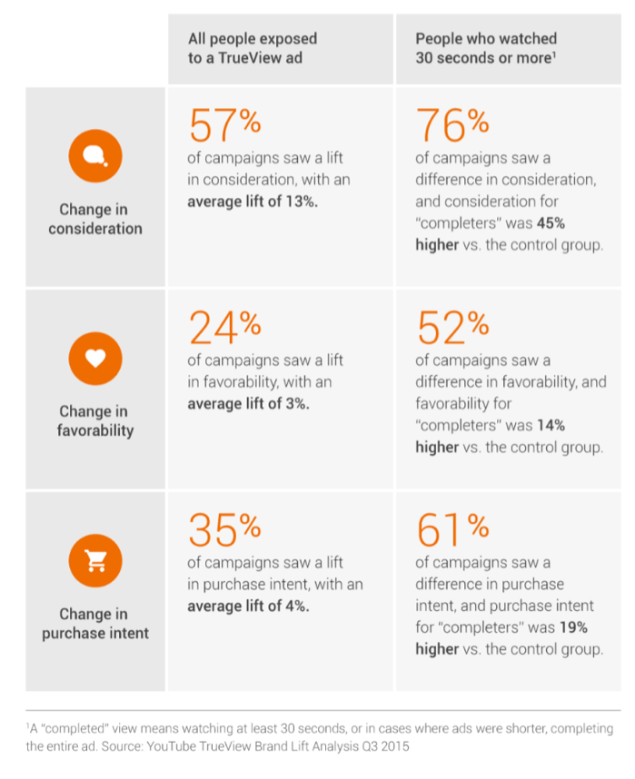

**Appendix 2:** Framework for measuring purchase intent (Spears and Singh 2013).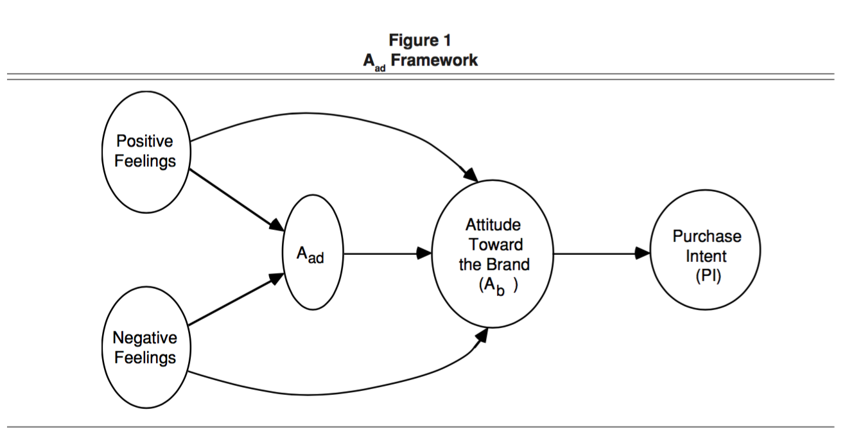

**Appendix 3:** Online video adverts characteristics, independent variables (Goodrich et al 2015).

|  |  |
| --- | --- |
| **Characteristics of online video advertisements (Goodrich et al 2015).** | **Explained** |
| **Length** | A “fair” duration is likely to vary because of factors such as, expectations, viewing anticipation and usefulness or enjoyment of OVA content (Goodrich et al 2015). Therefore, it becomes difficult to draw proportional correlations to a representative sample if the length is affected by a number of other factors. |
| **Informational** | Shavitt et al (1998) found that, consumers considered information as a positive facet of advertising when they learned about new products, benefits, and comparative product information. |
| **Entertainment** | Entertaining advertising is considered important for advertisers because they believe that it increases the effectiveness of their message. Entertaining ads are seen to generate more positive brand attitudes (Shimp, 1981; Logan et al 2012). This is ambiguous and will be tested in the primary research. |
| **Intrusiveness** | Intrusiveness and annoyance usually leads to negative attitudes towards an advertisement that can drive down brand attitudes (Mackenzie and Lutz 1989) and lead to advertisement avoidance (Speck and Elliott 1997). This characteristic will be tested further. |
| **Attitude and Intention** | Likeability (or attitude towards an advertisement) is important for generating positive advertising results and more effectively in perception and persuasion (Stapel 1994). |

**Appendix 4**: Saunders research onion (Saunders et al 2012).

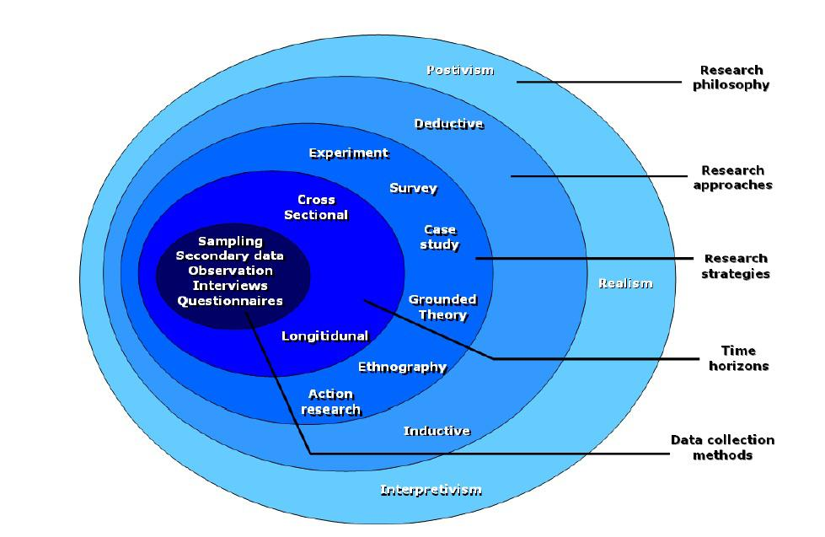

**Appendix 5**: Opening of the online questionnaire

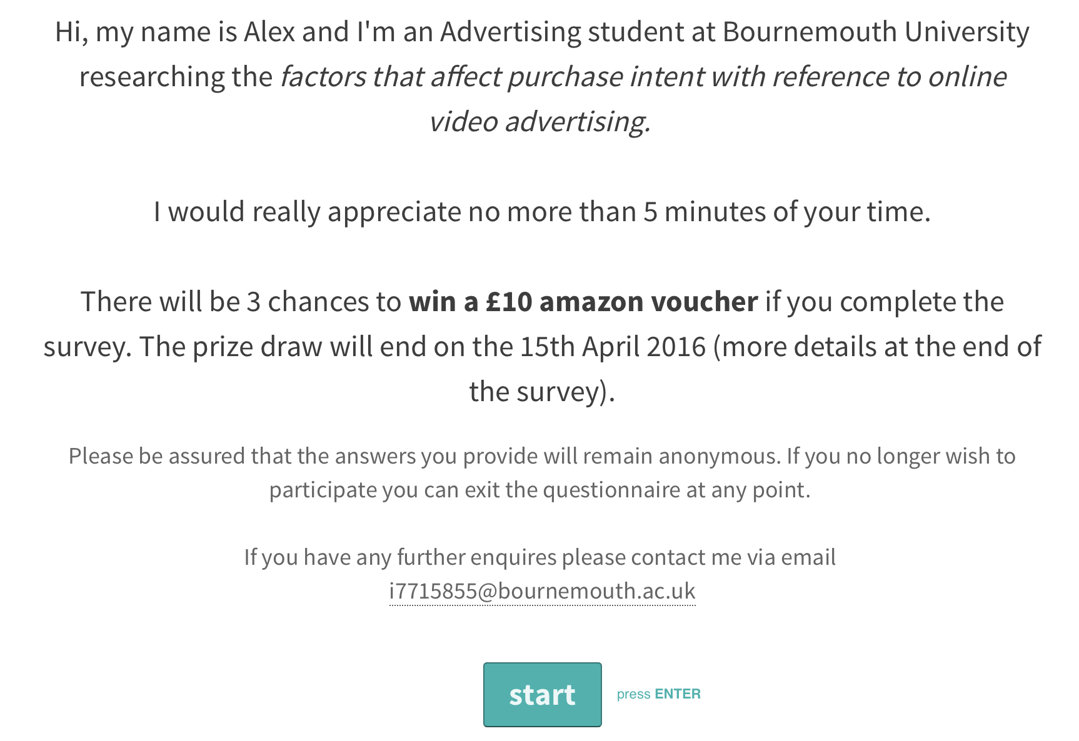

**Appendix 6:** A screening question asked viewers if they had watching an online video advert before to determine if they were suitable for the survey.

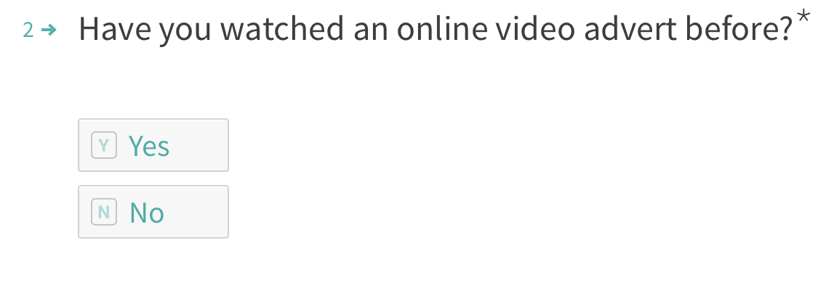

**Appendix 7:** Screening Question to measure brand awareness of the OVA watched by participants

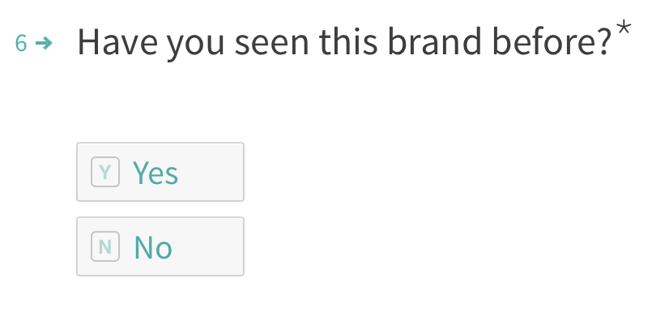

**Appendix 8:** Ethics Checklist



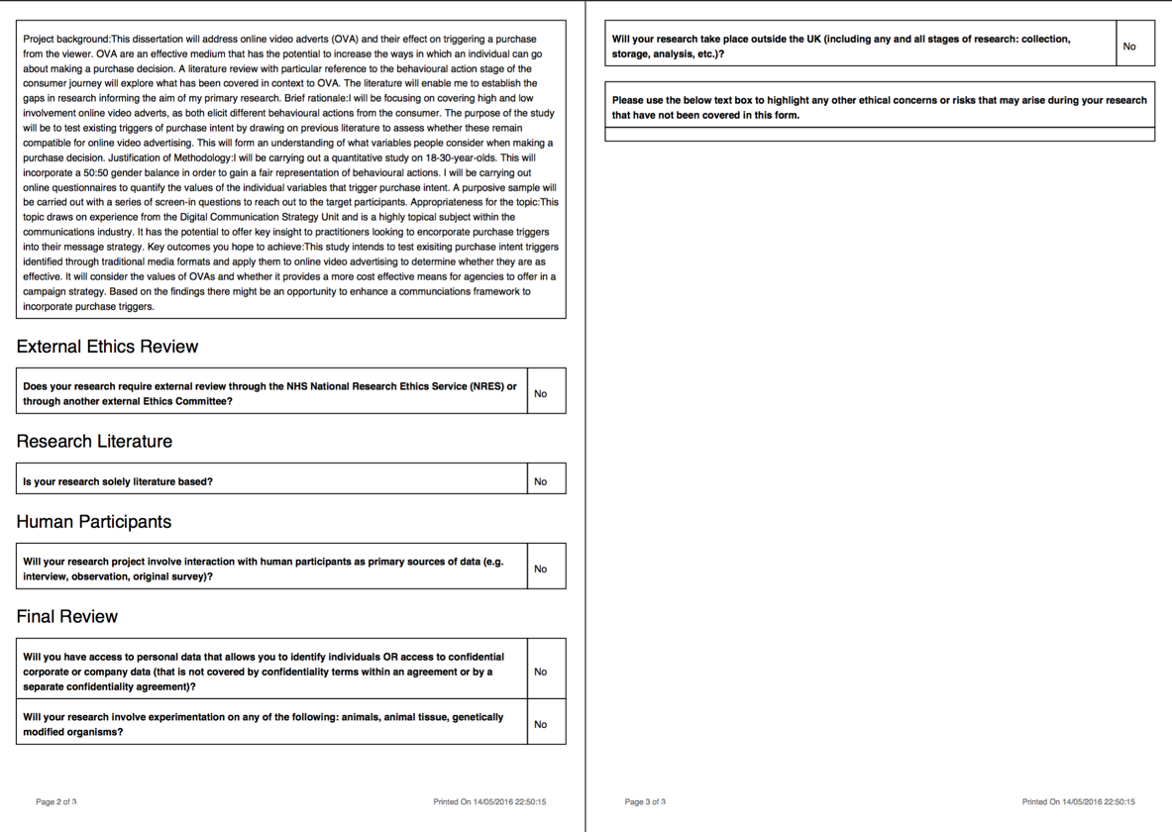

**Appendix 9:** Non parametric tests to be carried out on SPSS (Dewhurst 2002; Curwin and Slater 2008; Bryman and Bell 2011).

|  |  |  |  |
| --- | --- | --- | --- |
| **Test Category** | **Explained** | **Reasoning** | **Questions Used** |
| **Wilcoxon signed-rank test** | Used when comparing two related samples, matched samples, or repeated measurements on a single sample to assess whether their population means ranks differ (i.e. it’s a paired difference test). | Testing gender attitudes | ? |
| **Mann-Whitney U** | [Nonparametric](https://en.wikipedia.org/wiki/Nonparametric_statistics) [test](https://en.wikipedia.org/wiki/Statistical_hypothesis_test) of the [null hypothesis](https://en.wikipedia.org/wiki/Null_hypothesis) that two samples come from the same population against an [alternative hypothesis](https://en.wikipedia.org/wiki/Alternative_hypothesis), especially that a particular population tends to have larger values than the other.  Unlike the [*t*-test](https://en.wikipedia.org/wiki/T-test) it does not require the assumption of [normal distributions](https://en.wikipedia.org/wiki/Normal_distribution). It is nearly as efficient as the *t*-test on normal distributions. It will be used for testing gender. | A Mann-Whitney U based test has been conducted because the research design contains Likert scales within that enable… | 5 |
| **Spearman’s Correlation Coefficient** | Designed for the use of pairs of ordinal variables. It is exactly the same as Pearson’s r in terms of outcome of calculating in it, in that the computed value of rho will be either positive or negative and will vary between 0 and 1. | To measure if there is a correlation between two variables. | 14, 18, 20, 23, 31, 34, 37, 40. |

**Appendix 10:** Response rate of questionnaires



**Appendix 11:** Mann-Whitney U test between high involvements watched by male and female respondents.

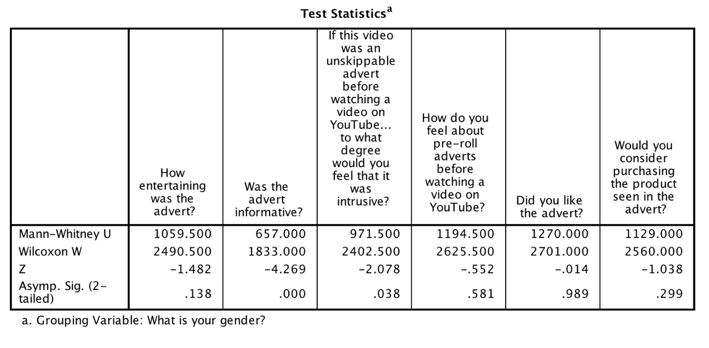

**Appendix 12:** Spearman correlation test for high involvement findings, males

|  |  |  |  |  |  |
| --- | --- | --- | --- | --- | --- |
| **Base** | **N** | **Independent Variables** | **Correlation test between variable and purchase consideration.** | **Null Hypothesis** | **Result** |
| Male | 48 | Entertainment | rs= .266  p .034 | There is no relationship between a highly **entertaining** OVA and purchasing the product seen in the ad. | Rejects |
| Informativeness | rs= .334  p .010 | There is no relationship between a highly **informative** OVA and purchasing the product seen in the ad. | Rejects |
| Irritation | rs= -0.341  p .009 | There is no relationship between a highly **irritating** OVA and purchasing the product seen in the ad. | Accepts |

**Appendix 13:** Spearman correlation test for high involvement findings, females

|  |  |  |  |  |  |
| --- | --- | --- | --- | --- | --- |
| **Base** | **N** | **Independent Variables** | **Correlation between would you consider purchasing the product.** | **Hypothesis** | **Result** |
| Female | 53 | Entertainment | rs= .397  p.002 | There is no relationship between a highly **entertaining** OVA and purchasing the product seen in the ad. | Rejects |
| Informativeness | rs= .566  p.000 | There is no relationship between a highly **informative** OVA and purchasing the product seen in the ad. | Rejects |
| Irritation | rs= -.037  p.397 | There is no relationship between a highly **irritating** OVA and purchasing the product seen in the ad. | Insufficient |

**Appendix 14:** Spearman correlation test for low involvement correlation test, males

|  |  |  |  |  |  |
| --- | --- | --- | --- | --- | --- |
| **Base** | **N** | **Independent Variables** | **Correlation** | **Null Hypothesis** | **Result** |
| Male | 48 | Entertainment | rs= .585  p .000 | There is no relationship between a highly **entertaining** OVA and purchasing the product seen in the ad. | Rejects |
| Informativeness | rs= .230  p .000 | There is no relationship between a highly **informative** OVA and purchasing the product seen in the ad. | Rejects |
| Irritation | rs= -.514  p .000 | There is no relationship between a highly **irritating** OVA and purchasing the product seen in the ad. | Supports |

**Appendix 15:** Spearman correlation test for Low involvement correlation test, females

|  |  |  |  |  |  |
| --- | --- | --- | --- | --- | --- |
| Female | 53 | Entertainment | rs= .641  p .000 | There is no relationship between a highly **entertaining** OVA and purchasing the product seen in the ad. | Rejects |
| Informativeness | rs= .415  p .001 | There is no relationship between a highly **informative** OVA and purchasing the product seen in the ad. | Rejects |
| Irritation | rs= -.310  p .12 | There is no relationship between a highly **irritating** OVA and purchasing the product seen in the ad. | Supports |

**Appendix 16:** Spearman correlation test between attitudes and intentions to purchase: high involvement, Male.

|  |  |  |  |  |  |  |
| --- | --- | --- | --- | --- | --- | --- |
| **Base** | **N** | **Dependent Variables** | **Mean Value** | **Spearman Correlation** | **Null Hypothesis** | **Result** |
| Male | 48 | How do you feel about pre-roll adverts? | 2.23 | rs= .236  p= .053 | There is no relationship between **positive pre-existing** **attitudes** and intentions to purchase. | Rejects |
| Did you like the advert? | 2.71 | rs= .298  p= .020 | There is no relationship between **likeability towards the advert** and intentions purchase. | Rejects |

**Appendix 17:** Spearman correlation test between attitudes and intentions to purchase: high involvement, female.

|  |  |  |  |  |  |  |
| --- | --- | --- | --- | --- | --- | --- |
| Female | 53 | How do you feel about pre-roll adverts? | 2.04 | rs= -.221  p= .056 | There is no relationship between **positive pre-existing attitudes** and intentions to purchase. | Supports |
| Did you like the advert? | 2.77 | rs= .583  p= .000 | There is no relationship between **likeability towards the advert** and intentions purchase. | Rejects |

**Appendix 18:** Spearman correlation test between attitudes and intentions to purchase: low involvement, male.

|  |  |  |  |  |  |  |
| --- | --- | --- | --- | --- | --- | --- |
| **Base** | **N** | **Dependent Variables** | **Mean Value** | **Spearman Correlation** | **Null Hypothesis** | **Result** |
| Male | 48 | How do you feel about pre-roll adverts? | 2.23 | rs= .266  p= .034 | There is no relationship between **positive pre-existing** attitudes and intentions to purchase. | Rejects |
| Did you like the advert? | 3.46 | rs= .557  p= .000 | There is no relationship between a positive attitudes towards the advert and intentions purchase. | Rejects |

**Appendix 19**: Spearman correlation test between attitudes and intentions to purchase: low involvement, female.

|  |  |  |  |  |  |  |
| --- | --- | --- | --- | --- | --- | --- |
| Female | 53 | How do you feel about pre-roll adverts? | 2.04 | rs= -.074  p= .300 | There is no relationship between positive **pre-existing attitudes** and intentions to purchase. | Invalid: this shows no correlation between the two. |
| Did you like the advert? | 2.77 | rs= .670  p= .000 | There is no relationship between a **positive attitude** towards the advert and intentions purchase. | Rejects |

**Appendix 20:** Wilcoxon Signed Rank Test comparing the question: would you consider purchase product seen in the advert for high and low Involvement, males.

|  |  |  |  |  |
| --- | --- | --- | --- | --- |
|  | **Ranks** | **N** | **Mean Rank** | **Sum of Ranks** |
| Would you consider purchasing the product seen in the advert? High- Would you consider purchasing the product seen in the advert? Low | Negative Ranks  Positive Ranks  Ties  Total | 2a  32b  14c  48 | 4.50  18.31 | 9.00  586.00 |

1. Would you consider purchasing the product seen in the advert? High < Would you consider purchasing the product seen in the advert? Low
2. Would you consider purchasing the product seen in the advert? High > Would you consider purchasing the product seen in the advert? Low
3. Would you consider purchasing the product seen in the advert? High = Would you consider purchasing the product seen in the advert? Low

|  |  |
| --- | --- |
|  | Would you consider purchasing the product seen in the advert? High- Would you consider purchasing the product seen in the advert? Low |
| **Z**  **Asymp. Sig (2- tailed)** | **-4.965b**  **.000** |

1. Wilcoxon Signed Ranks Test.
2. Based on negative ranks.

**Appendix 21**: Wilcoxon Signed Rank Test comparing the question: would you consider purchase product seen in the advert? for high and low involvement, Females.

|  |  |  |  |  |
| --- | --- | --- | --- | --- |
|  | **Ranks** | **N** | **Mean Rank** | **Sum of Ranks** |
| Would you consider purchasing the product seen in the advert? High- Would you consider purchasing the product seen in the advert? Low | Negative Ranks  Positive Ranks  Ties  Total | 2a  43b  8c  53 | 16.50  23.30 | 33.00  1002.00 |

1. Would you consider purchasing the product seen in the advert? High < Would you consider purchasing the product seen in the advert? Low
2. Would you consider purchasing the product seen in the advert? High > Would you consider purchasing the product seen in the advert? Low
3. Would you consider purchasing the product seen in the advert? High = Would you consider purchasing the product seen in the advert? Low

|  |  |
| --- | --- |
|  | Would you consider purchasing the product seen in the advert? High- Would you consider purchasing the product seen in the advert? Low |
| **Z**  **Asymp. Sig (2- tailed)** | -5.525e  .000 |

1. Wilcoxon Signed Ranks Test.
2. Based on negative ranks.

**Appendix 22**: Open-ended responses for: why respondents would consider purchasing the product seen in the ad: Low involvement

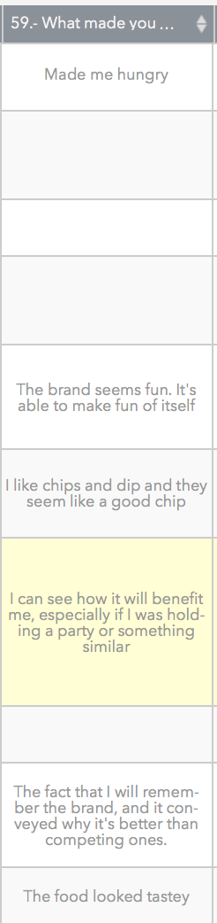

**Appendix 23:** Open-ended responses for: why respondents would not consider purchasing the product seen in the ad: High involvement

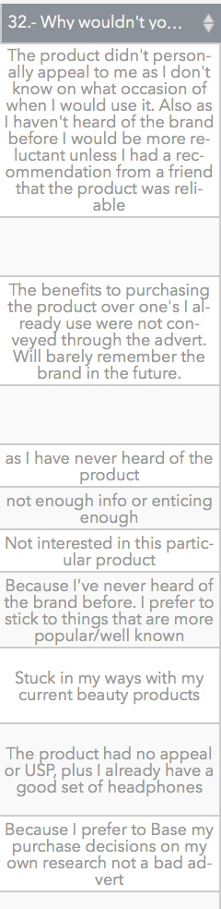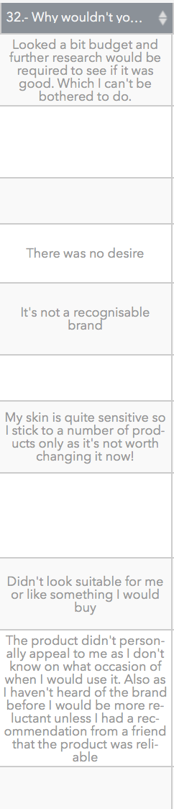  
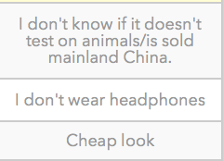

**Appendix 24:** Open-ended responses to what would increase their chances of purchasing the product seen in the ad: High involvement

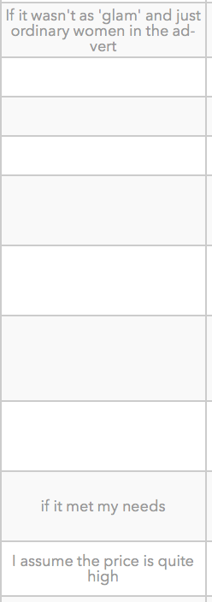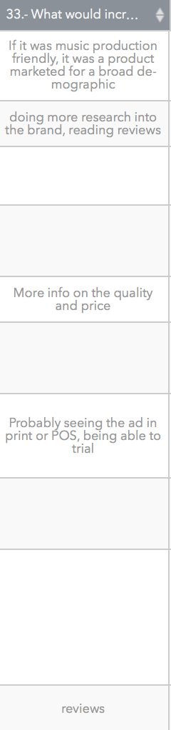

**Appendix 25:** Descriptive statistic, low involvement advert was twice as effective in triggering a purchase consideration for both genders.

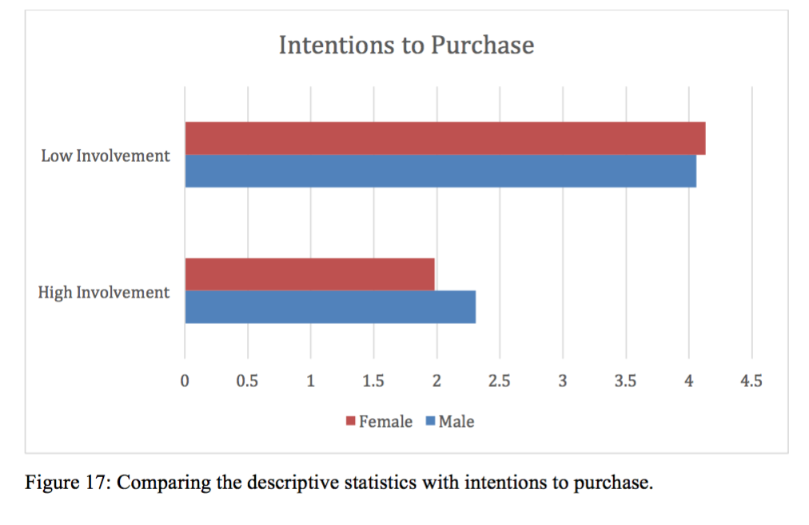

**Appendix 26:** Results from Low Involvement purchase consideration question



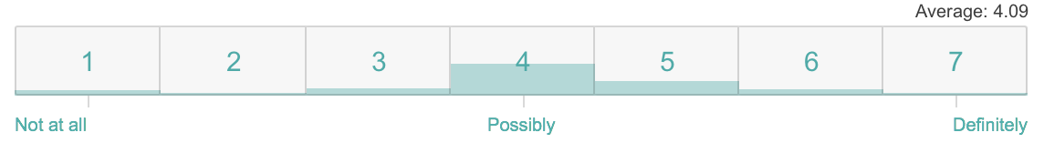

**Appendix 27:** Question what respondents felt about the advert



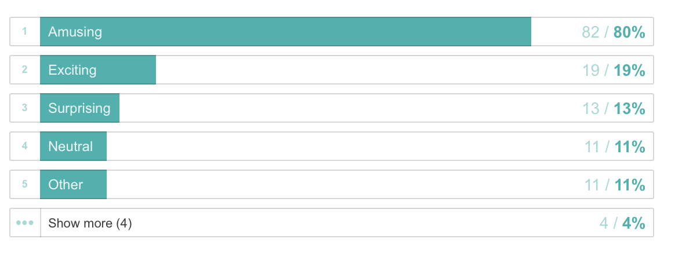

**Appendix 28:** TrueView introduced their click-to-shop feature, but will this lift purchase intent (Peterson 2015).



**Appendix 29:** High Involvement advert: Males. SMS Audio headphones. Non-skippable playback controls. 30 seconds (SMS by 50 2013).



**Appendix 30:** High Involvement advert: Females Beauty Magic. Non-skippable playback controls. 30 seconds (M&C Saatchi 2013).



**Appendix 31:** Low Involvement Ad. FMCG low brand awareness: Tostitos. Non-skippable playback controls to imitate a pre-roll advert, 30 seconds long (LA Egotist 2012).



**Appendix 32:** Overview of Questionnaire

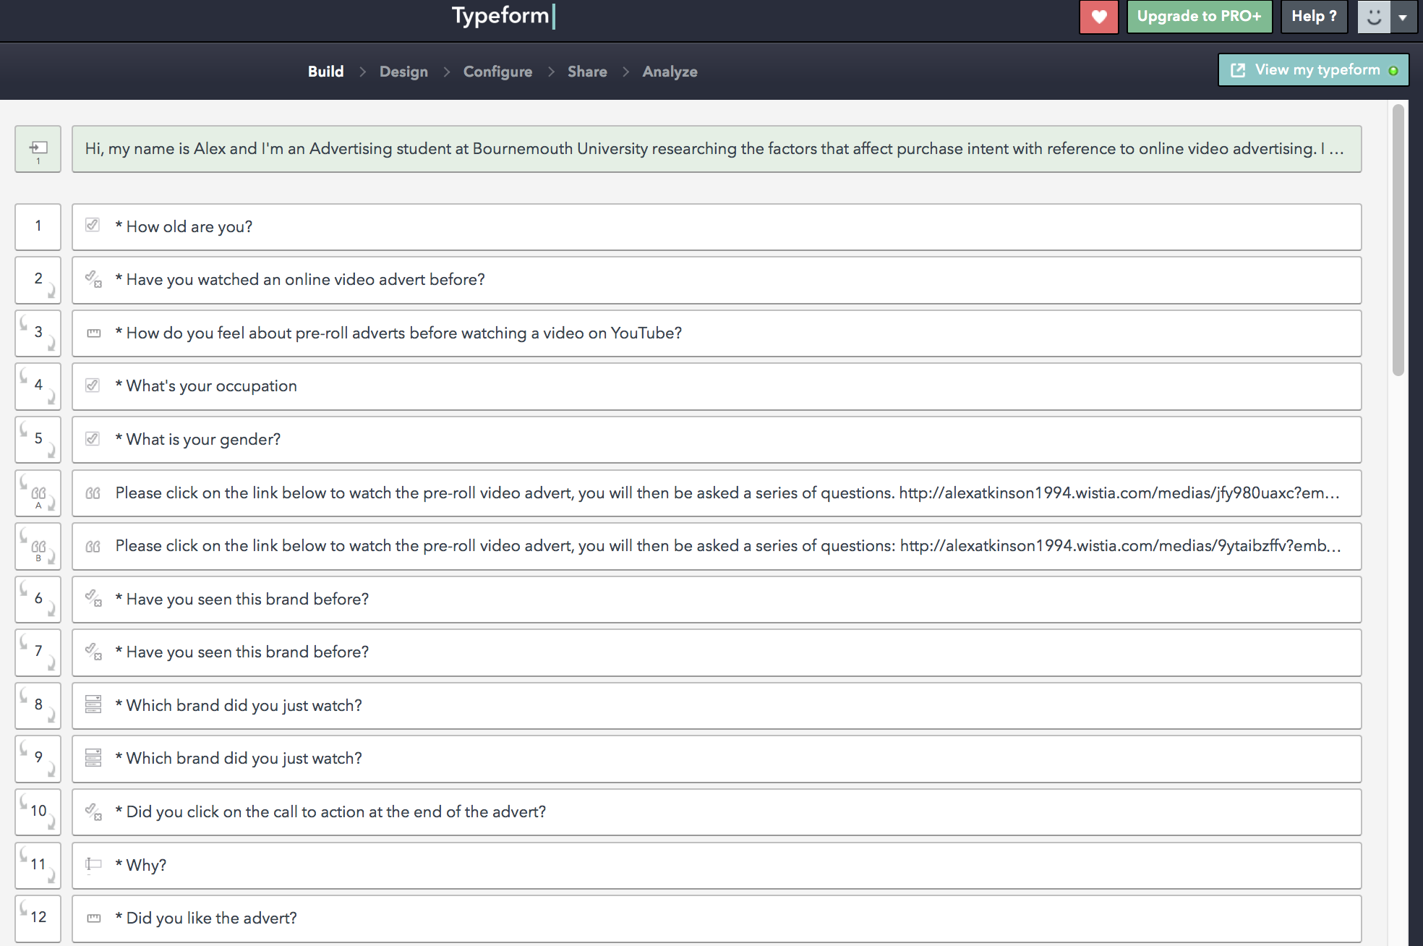

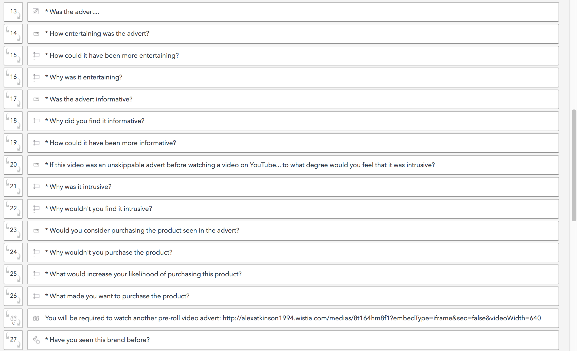

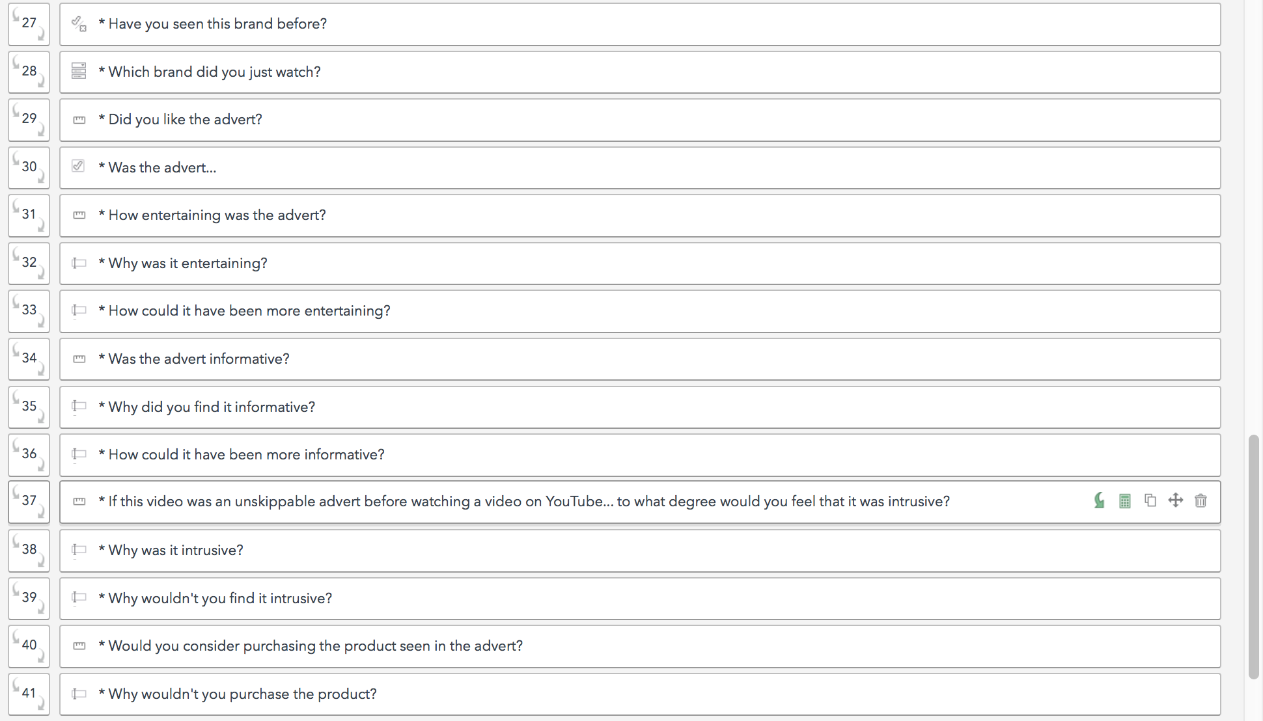

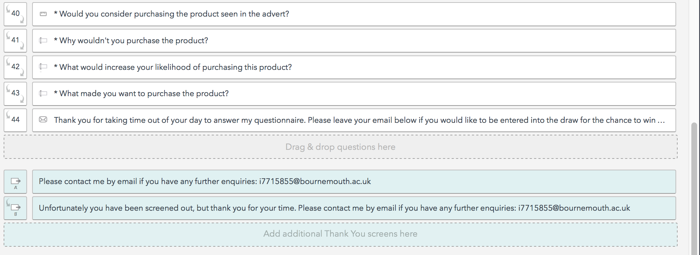

# Research Ethics Forms

**Appendix 8:** Ethics Checklist





# Manuscript

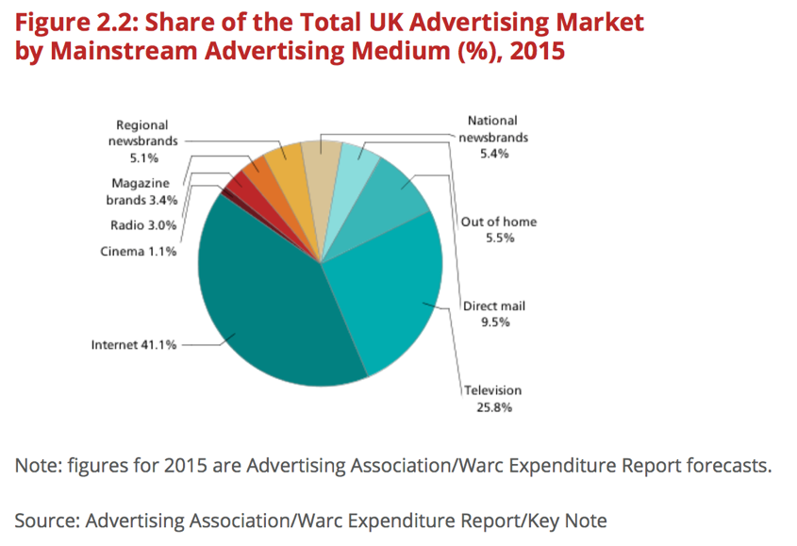

**Figure 1.** Share of the Total UK Advertising Market by Mainstream Advertising Medium (%) (Key Note 2015)

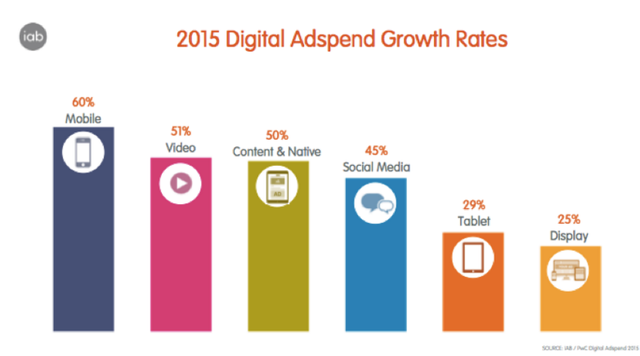

**Figure 2.** Digital Advertising Formats in the UK (IAB 2015)

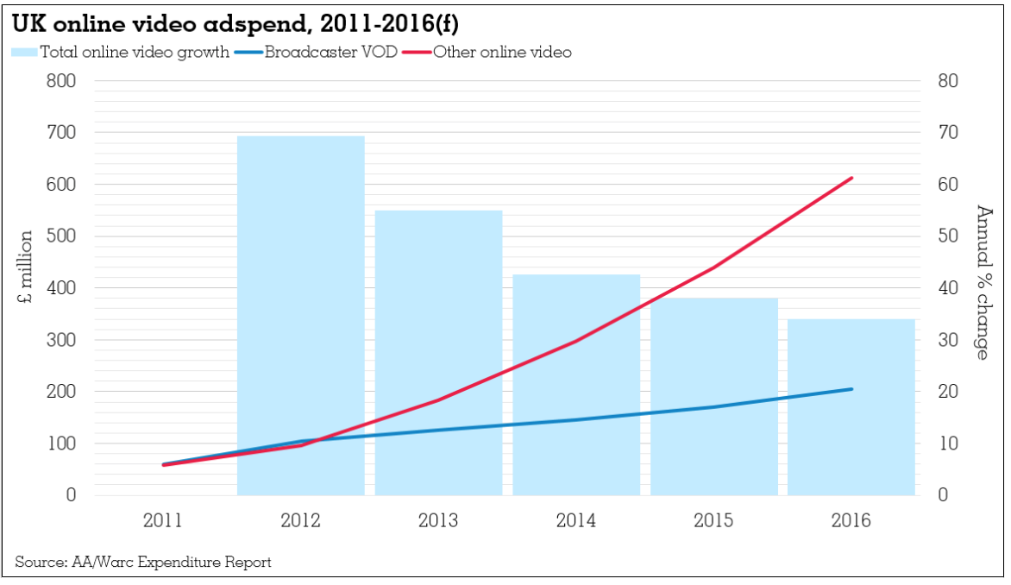

**Figure 3.** UK Online Video adspend (Mcdonald 2015)

**Table 2.11 Consumer Behaviour models (Katz 1960; Fishbein and Ajzen 1975; Krugman 1965)**

|  |  |  |
| --- | --- | --- |
| **Model** | **Strengths** | **Limitations** |
| **ABC Model of Attitudes** | Mainly the findings show the strength with which an attitude is held is often a good predictor of behaviour (Lee and Lee 2011). Therefore, the stronger the attitude the more likely it should affect behaviour. Lee and Lee’s (2011) study on factors influencing intentions to watch OVAs found the more positive an attitude towards an OVA, the more likely an individual would watch it. These findings are very useful in supporting objective 2 and will be tested in the research. | The model provides a basis to forming attitudes, there are levels of commitment to an attitude that lie deeper beyond its purpose (Solomon et al 2013). Difficulties arise when attempting to explore cognitive and behavioural effects of OVAs. Lee and Lee (2011) acknowledge that other behavioural beliefs for watching OVAs did not predict their attitudes towards watching ads. |
| **Theory of Reasoned Action (TRA)**  http://is.theorizeit.org/w/images/6/60/Tra.JPG | TRA assumes that the best predictor of behaviour is intention (Fishbein and Ajzen 1975). When tested on OVAs, a more positive attitude towards the act or behaviour increases behavioural intention, leading to a behavioural action (Lee and Lee 2011). A number of studies have found strong and positive relationships between behavioural intention and actual behaviour because people tend to perform behaviours that they plan to execute (Bagozzi, Baumgartner, and Yi 1992; Choo, Chung, and Pysarchik 2004; Conner and Armitage 1998; Oliver and Bearden 1985; Ryan and Bonfield 1980; Lee et al 2013). The model predicts that behavioural intent is created or caused by two factors: attitudes and subjective norms. | TRA assumes attitudes towards a behaviour is determined by behavioural beliefs, a “person’s beliefs that the behaviour leads to certain outcomes and his evaluations of these outcomes” (Lee and Lee 2011 p. 620). Fishbein (1980) explicitly acknowledged their model’s limitation concerning the distinction between goal intention and behavioural intention. The model was developed to deal with behaviours, not outcomes or events that result from behaviours (Sheppard et al. 1988). This presents a clear weakness in the model because it doesn’t give explanation about how outcomes are triggered, which must be established in satisfying objective 2. |
| **Involvement Theory** | Involvement is the degree of personal relevance and risk perceived by consumers when making a particular purchase decision (Bauer et al. 2006; Rossiter et al. 1991; Heath 2001).  Involvement theory is useful in understanding the fundamental premise of the decision-making process. The theory can be used to identify two main approaches to consumer decision-making: high and low involvement (Fill 2013). These approaches lead to two uses of marketing communications. The model will be applied in the research testing objective 3, being useful to inform objectives 1 and 2. | The model implies the level of involvement may vary through time as each member of the target market becomes more familiar with the purchase and associated communications (Fill 2013). This is supported by McQuarrie and Munson (1992 p. 108) as “clearly, allegiance to one or another theoretical position is going to have marked effects on how one measures the construct”. A major limitation as the levels of involvement can vary based on the individual. |
| **High Involvement decision-making** |
| **Low Involvement decision-making** |

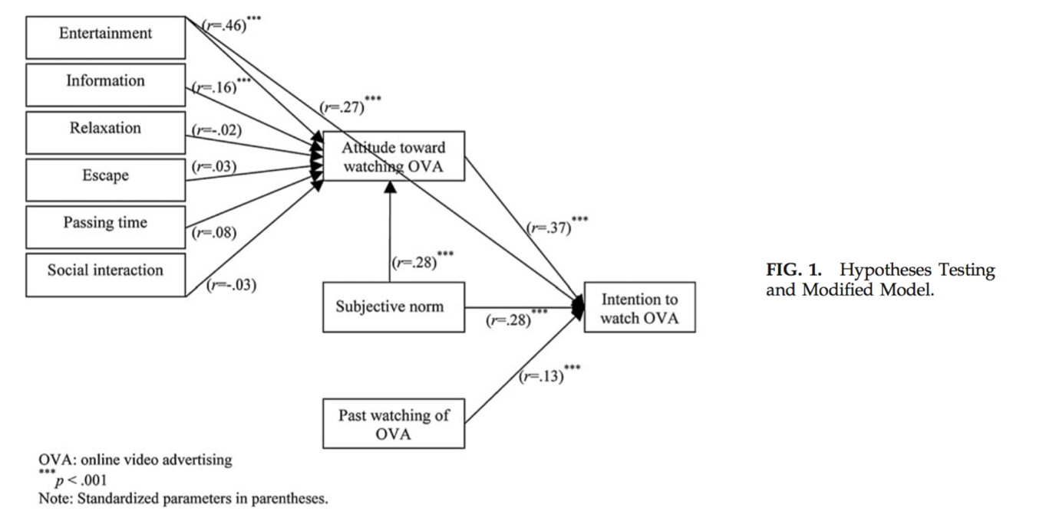

**Figure 4.** Hypothesis model, intentions to watch OVA (Lee and Lee 2011, p. 622)

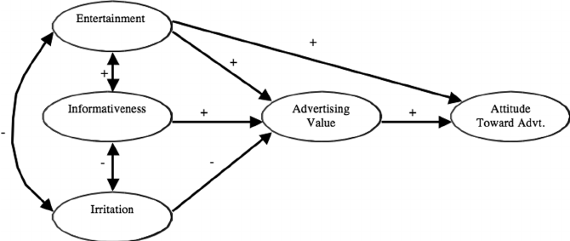

**Figure 5.** Advertising Value Model (Ducoffe 1995; 1996).

|  |  |
| --- | --- |
| **Independent Variables (perceptions towards the advert)** | **Dependent Variables (attitudes)** |
| Informativeness | Did you like the advert? |
| Entertainment | Attitudes towards the product? |
| Irritation | How do you feel about in-stream adverts? |

**Figure 6.** Framework for assessing advertising value (Ducoffe 1996; Logan et al 2012; Goodrich et al. 2015)

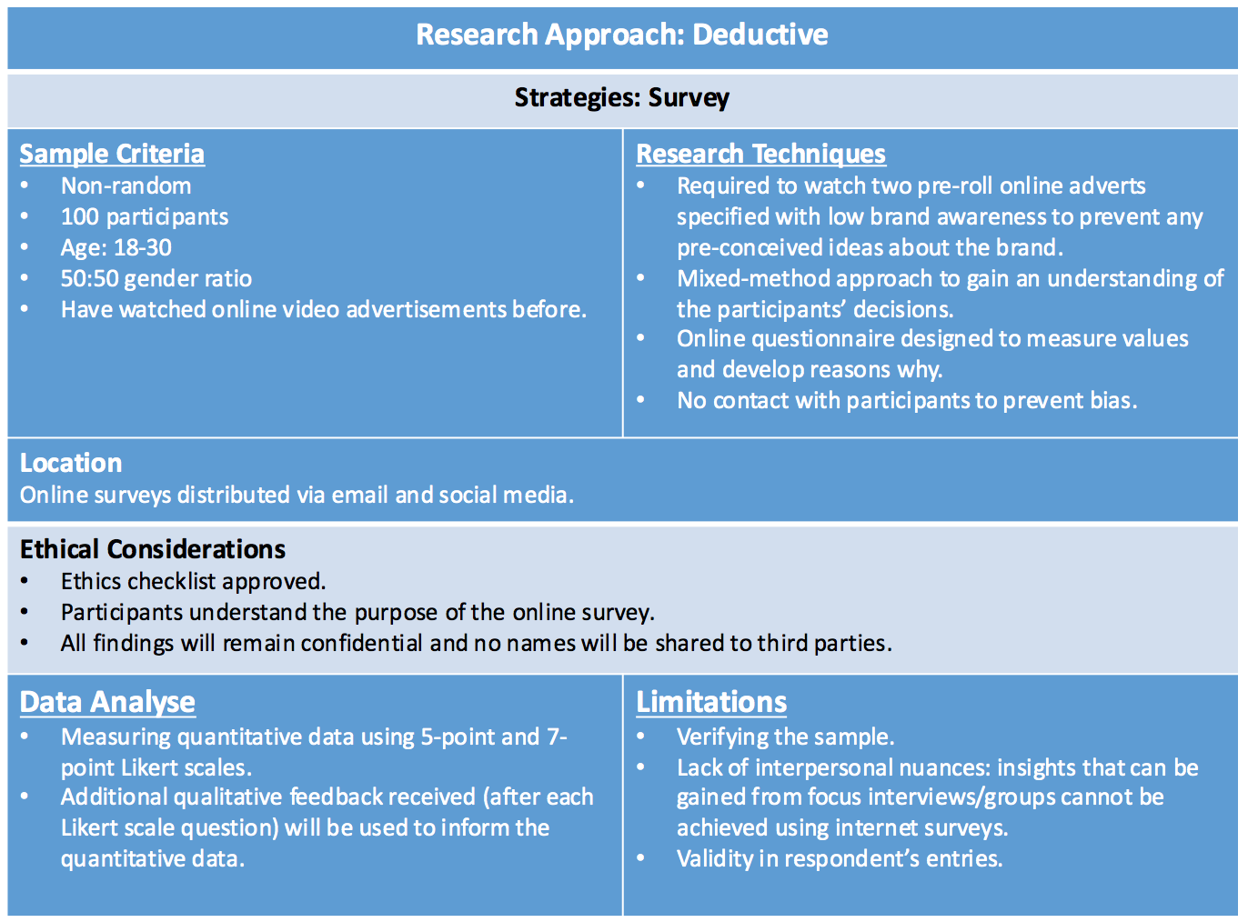

**Figure 7.** Methodology Design (Author: Atkinson 2016)



**Table 3.2** Research Plan

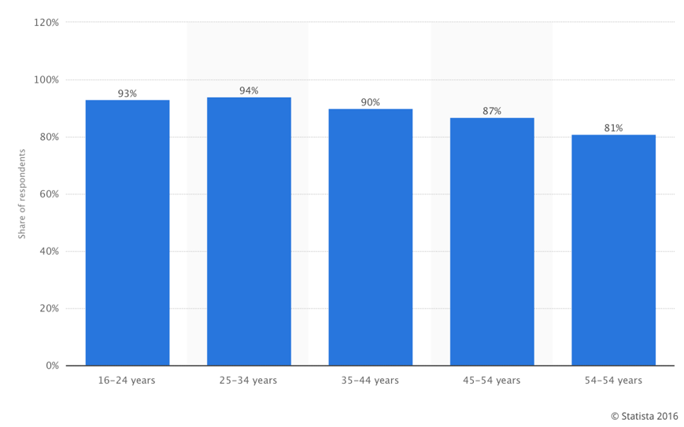

**Figure 8.** Online video viewing penetration among internet users worldwide, by age group. Q1 2016 (Statista 2016)

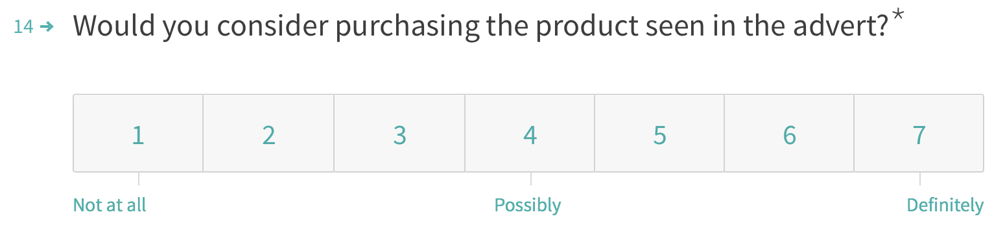



**Figure 9.** Personalised open-ended questions are affected by Likert scale responses.



**Figure 10**. Male (headphones), 30 seconds (SMS by 50 2013).



**Figure 11**. Female (beauty products), 30 seconds (M&C Saatchi 2013)



**Figure 12.** Low Involvement ad featuring FMCG product, 30 seconds (LA Egotist 2012).

**1.**



**2.**



**Figure 13.** By Clicking on the link (1), you are a taken to a microsite where the pre-roll video will auto-play (2) between answering questions.

**Figure 14:** Number of Respondents by Gender. Male (48) & Female (53).

**Figure 15:** Age of Respondents %. 18-21 (41), 22-25 (51), 26-30 (9).

|  |  |  |  |
| --- | --- | --- | --- |
| **Type of Advert** | **Gender** | **Yes** | **No** |
| High Involvement (appendix 31) | M | 14% | 86% |
| High Involvement (appendix 32) | F | 0 | 100% |
| Low Involvement  (appendix 33) | M/F | 9 % | 91% |

**Figure 16.** Brand Awareness test.

**Figure 17:** Comparing the descriptive statistics with intentions to purchase.

**Figure 18:** Summary of Independent Variables

|  |
| --- |
| Objective **1**: Entertainment must be high for a low involvement ad to trigger purchase intent. Informativeness must be stronger for a high involvement ad in driving purchase intent. |
| Objective **2**: Positive attitudes increase likelihood of purchase consideration. |
| Objective **3**: Low involvement adverts generate high purchase consideration than high involvement. |

**Table 5.11.** Answering original research objectives

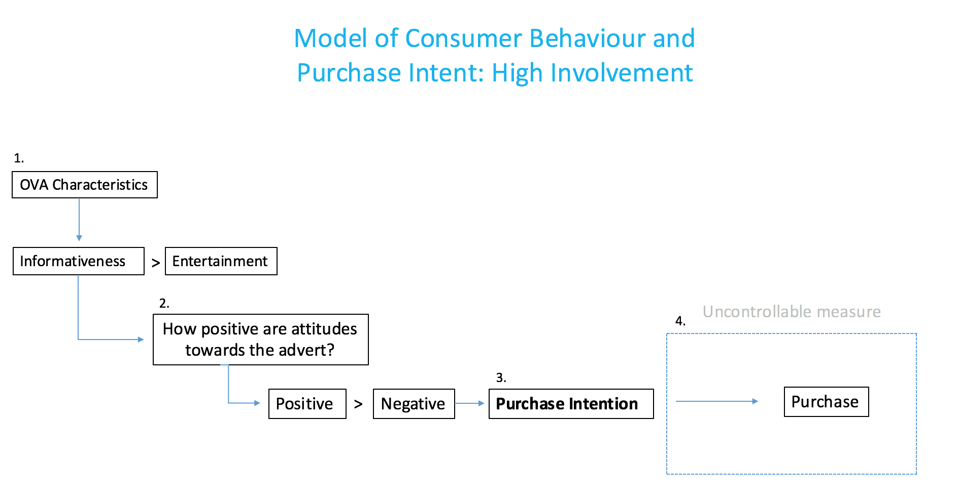

**Figure 19.** Framework for predicting purchase intent (Author: Atkinson 2016).

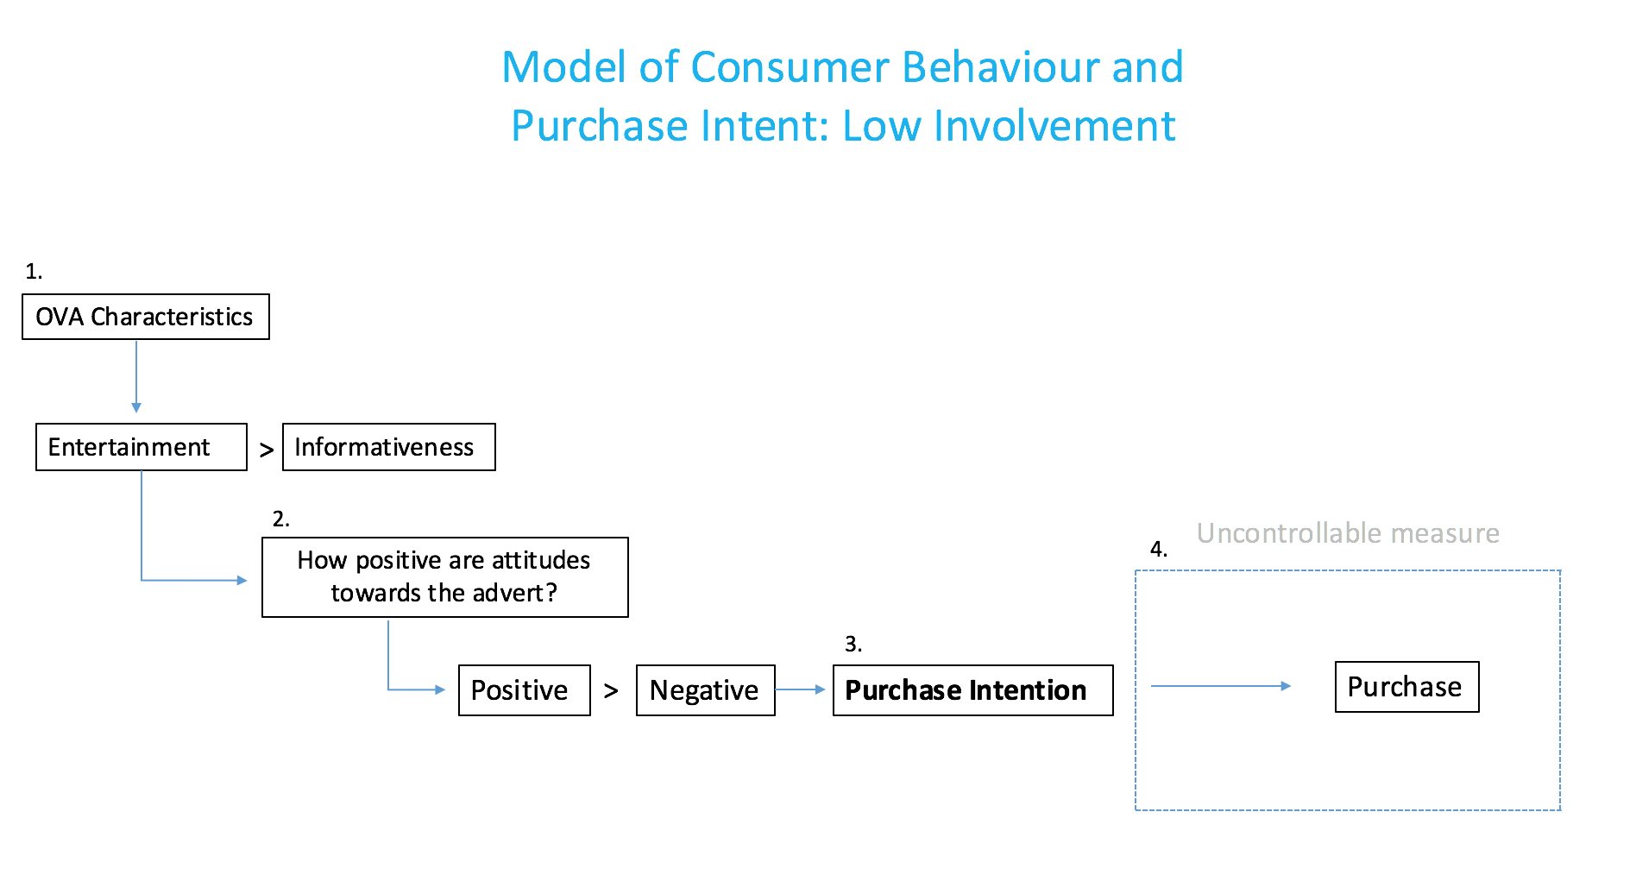

**Figure 20.** Framework for predicting purchase intent (Author: Atkinson 2016).



Click here to receive a sample

**Figure 21.** Driving purchase considerations with free trial and experimentation for high involvement beauty adverts.

**Figure 22.** Incorporate a call-to-action utilising location-based services inviting viewers to discover nearest store to sample product, providing personalised experience.



Find out where you can trial our latest products.